|  |  |
| --- | --- |
| Project Title | Design and develop a website portal using Liferay |
| Qualification Name (NICF) | Advanced Certificate in Web Development using Platforms |
| Product Name | Triple – A (AAA) Hosting |
| Module Name (NICF) | Development using Platforms |

Project Report

|  |  |  |  |
| --- | --- | --- | --- |
| Student name | | Assessor name | |
| Chathushi Jayarathna | | MS. Aravinder Kaur | |
| Date issued | Completion date | | Submitted on |
| 11/04/2022 | 12/05/2022 | | 12/19/2022 |
|  | |  | |
| Project title | Design and develop a website portal using Liferay | | |

|  |
| --- |
| Learner declaration |
| I certify that the work submitted for this assignment is my own and research sources are fully acknowledged.  Student signature: **Chathushi** |

Table of Contents

1. Project Background 4

2. Project Objective 5

2.1 Tools and Platform 5

3.1 Project Scope 6

4. Object Oriented Programming paradigm 7

4.1 Characteristics of the Object-Oriented Programming Paradigm 8

4.1.1 Encapsulation 8

4.1.2 Polymorphism 8

4.1.3 Constructors/ Destructors 9

4.1.4 Abstract 10

4.1.5 Interface 11

4.1.6 Differences between abstract classes and interfaces 12

4.2 Class Relationships using UML diagrams 12

4.2.1 Inheritance 12

4.2.2 Realization 13

4.2.3 Dependency 13

4.2.4 Aggregation 14

4.2.5 Composition 14

5. Suitable design patterns based on the AAA Portlet 14

5.1 Creational design pattern 14

5.2 Suitable creational design pattern for “AAA Portlet” 15

5.3 Structural design pattern 15

5.4 Suitable structural design pattern for “AAA Portlet” 16

5.5 Behavioral design pattern 16

5.6 Suitable behavioral design pattern for “AAA Portlet” 17

6. How the object-orientated paradigm and its key principle are identified in each of the design patterns. 18

7. Class Diagrams showing Class-relationships 19

8. Possible situations where design patterns would be beneficial 19

8.1 Where should we use Design Patterns 19

8.2 Benefit of Design Patterns 19

9. Observe how the class diagrams are reflected from a given scenario by using the UML tool 22

10. Set up a project, and build an application based on derived UML class diagrams and design patterns. Provide screenshots as evidence. 23

11. Develop an application that implements design patterns and utilizes techniques to produce secure code. Provide the implemented code as evidence. 37

11.1 In your “AAA Customer Management Application”, show the developed code 37

11.2 The techniques have been utilized to produce secure code 38

12. Use of design patterns for the given purpose and consequences by applying design patterns. 38

12.1 Usage of design patterns in the “AAA Customer Management Portlet” 38

12.2 The consequences of design patterns that you have used in your project. 39

13. How different design patterns can work within a range of different scenarios. 39

14. The appropriate design pattern from the investigation. 43

14.1 Among 3 different scenarios in creational design which you have analyzed in P4, reconcile the most appropriate design pattern 43

14.2 Among 3 different scenarios in structural design which you have analyzed in P4, reconcile the most appropriate design pattern 43

14.3 Among 3 different scenarios in behavioural design which you have analyzed in P4, reconcile the most appropriate design pattern 44

15. Evaluate and justify the design patterns that you had identify in each of the scenarios. 44

16. Developed pages 46

Figure 1:Screenshot of Developer Studio (Liferay IDE) 7

Figure 2:Screenshot of MySQL Workbench 8

Figure 3:Screenshot of creately.com 8

Figure 4:Example for OOP Concept - Class 11

Figure 5:Example for OOP Concept - Object 12

Figure 6:Example for OOP Concept - Methods 13

Figure 7:Example for OOP Concept - Encapsulation 13

Figure 8:Example for OOP Concept - Polymorphism 14

Figure 9:Example for OOP Concept - Construcators 15

Figure 10:Example for OOP Concept - Abstract 16

Figure 11:Example for OOP Concept - Interface 17

Figure 12:Example for Inheritance 19

Figure 13:Example for Realization 19

Figure 14:Example for Dependency 20

Figure 15:Example for Aggregation 20

Figure 16:Example for composition 21

Figure 17:Example for encapsulation 27

Figure 18:Example for abstraction 28

Figure 19:Example for Inheritance 29

Figure 20:Example for Polymorphism 31

Figure 21:Class Diagram 32

Figure 22:Example for facade pattern 34

Figure 23:Factory Pattern 35

Figure 24::Example for factory pattern 35

Figure 25::Example for template pattern 36

Figure 26:Screenshot of project setup 1 38

Figure 27:Screenshot of project setup 2 38

Figure 28:Screenshot of build required entities for AAA Customer Portlet 39

Figure 29:Screenshot of service layer 2 40

Figure 30:Screenshot of service layer 1 40

Figure 31:Screenshot of service.xml 41

Figure 32:Screenshot of Portlet Controller 43

Figure 33:Screenshot of View (JSP files) 44

Figure 34:Screenshot of CutomerAction.jsp 45

Figure 35:Screenshot of Init.jsp 45

Figure 36:Screenshot of ServiceAction.jsp 46

Figure 37:Screenshot of updateCustomer.jsp 47

Figure 38:Screenshot of updateService.jsp 48

Figure 39:Screenshot of view.jsp 48

Figure 40:Screenshot of viewCustomer.jsp 49

Figure 41:Screenshot of viewService.jsp 50

Figure 42:Screenshot of Home page 51

Figure 43:Screenshot of About Us page 52

Figure 44:Screenshot of Contact us page 53

Figure 45:Screenshot of Contact Us Page 53

Figure 46:Screenshot of Our Services Page 54

Figure 47:Screenshot of Our Services Page 54

Figure 48:Screenshot of Domain Name Page 55

Figure 49:Screenshot of Domain Name Page 55

Figure 50:Screenshot of Shared Hosting 56

Figure 51:Screenshot of Shared Hosting Page 56

Figure 52:Screenshot of Reseller Hosting page 57

Figure 53:Screenshot of Cloud Hosting page 58

Figure 54:Screenshot of VPS Hosting page 59

Figure 55:Screenshot of Dedicate Hosting Page 60

Figure 56:Screenshot of Colocation Server Hosting Page 61

Figure 57:Screenshot of Service 1 62

Figure 58::Screenshot of Service 2 62

Figure 59:Screenshot of Customer 2 63

Figure 60:Screenshot of Customer 1 63

Figure 61:Screenshot of terms & condtions 64

Figure 62:Screenshot of Administrator Login 65

Figure 63:Screenshot of Customer Login 67

Figure 64:Source Code Example for Encapsulation 68

Figure 65:Sourcr code example for Polymorphism 68

Figure 66:Source Code Example for Inheritance 69

Figure 67:Source Code Example for Abstraction 69

Figure 68:Factory Pattern 72

Figure 69:Singleton 73

Figure 70:Prototype 74

Figure 71:Adapter Pattern 75

Figure 72:Facade Pattern 75

Figure 73:Iterator Pattern 76

Figure 74:Observer Pattern 77

Figure 75:Screenshot of Registration page 81

Figure 76:Screenshot of Login page 82

Figure 77:Screenshot of Terms & Conditions 82

Figure 78:Screenshot of Home Page 83

Figure 79:Screenshot of About us Page 84

Figure 80:Screenshot of Contact us page 85

Figure 81:Screenshot of our service page 86

Figure 82:Screenshot of Domain Name Page 87

Figure 83:Screenshot of Shared Hosting Page 88

Figure 84:Screenshot of Reseller Hosting Page 89

Figure 85:Screenshot of Cloud Hosting Page 90

Figure 86:Screenshot of VPD Hosting Page 91

Figure 87:Screenshot of Dedicated Hosting Page 92

Figure 88:Screenshot of Colocation Server Hosting Page 93

Figure 89:Screenshot of Service 2 94

Figure 90:Screenshot of Service 1 94

Figure 91:Screenshot of Customer 2 95

Figure 92:Screenshot of Customer 1 95

1. **Project Background**

Triple-A (AAA) group is a pleasant internet host solutions provider enterprise located in downtown Sri Lanka. It affords all forms of services which consist of domain name registration, Shared website hosting, Reseller website hosting, Cloud website hosting, VPS hosting, dedicated website hosting, Colocation service, etc.

Customers can purchase their services from AAA’s department workplaces and wishes to offer private records which include call, email, address, national identity card number, and contact number. Clients' data is a totally important thing for AAA company. To maintain and manage all of their client information, AAA has decided to increase their application with an object-oriented method. Software is required to keep track of their customer’s info and services given to clients. The properly-prepared consumer facts can help the employer to pick the ideal recipients for promotions and new services.

1. **Project Objective**

This project is used for Summative assessment of students in the Module net development using structures of the NICF direction “implemented degree in Software Engineering” This challenge considers the skills required to layout, enforce, check & report a website for a Used car income Portal the use of Spring Framework, MySQL server and test the system via adopting risk-based testing (RBT).

The scope of this research was focused on the application Triple-A-A-A Company. The following scope will assist in achieving the goals,

* Develop the application under “System development”
* Create Documents which explain “System Design”
* Explain briefly the “Program Paradigm and design pattern”
* Evaluate the design patterns and document under “them Evaluation of Design Pattern”
* Provide screen Capture of developed Triple A-A-A Cars and hosted application

1. **Tools and Platform**

* 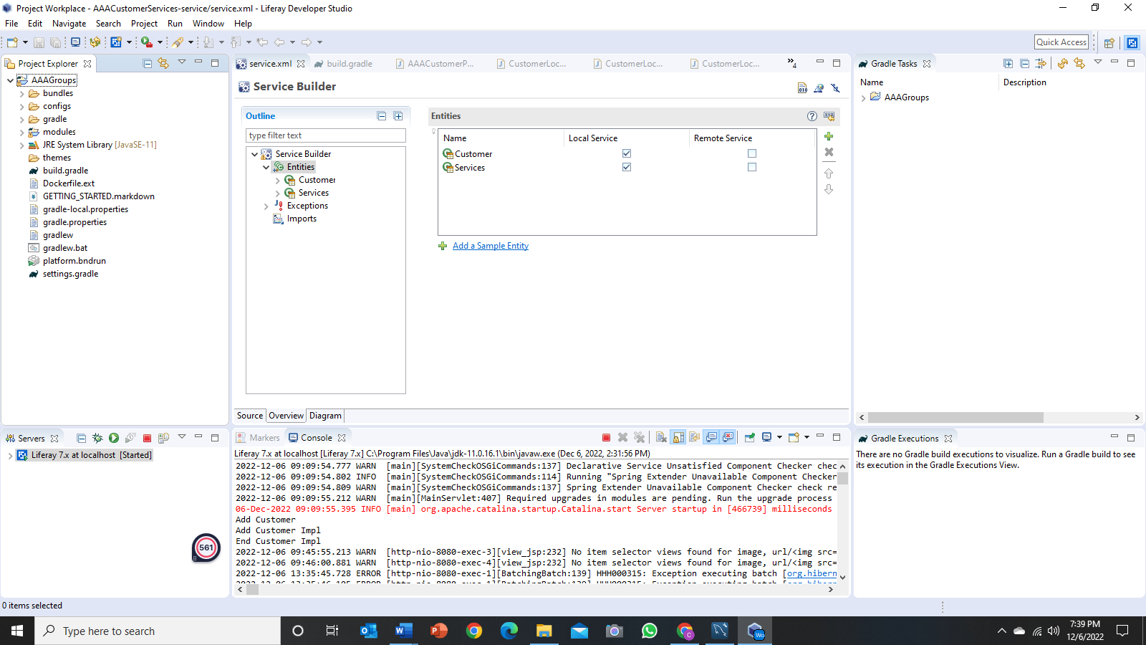**Developer Studio (Liferay IDE) –** To implement the project

Figure 1:Screenshot of Developer Studio (Liferay IDE)

* 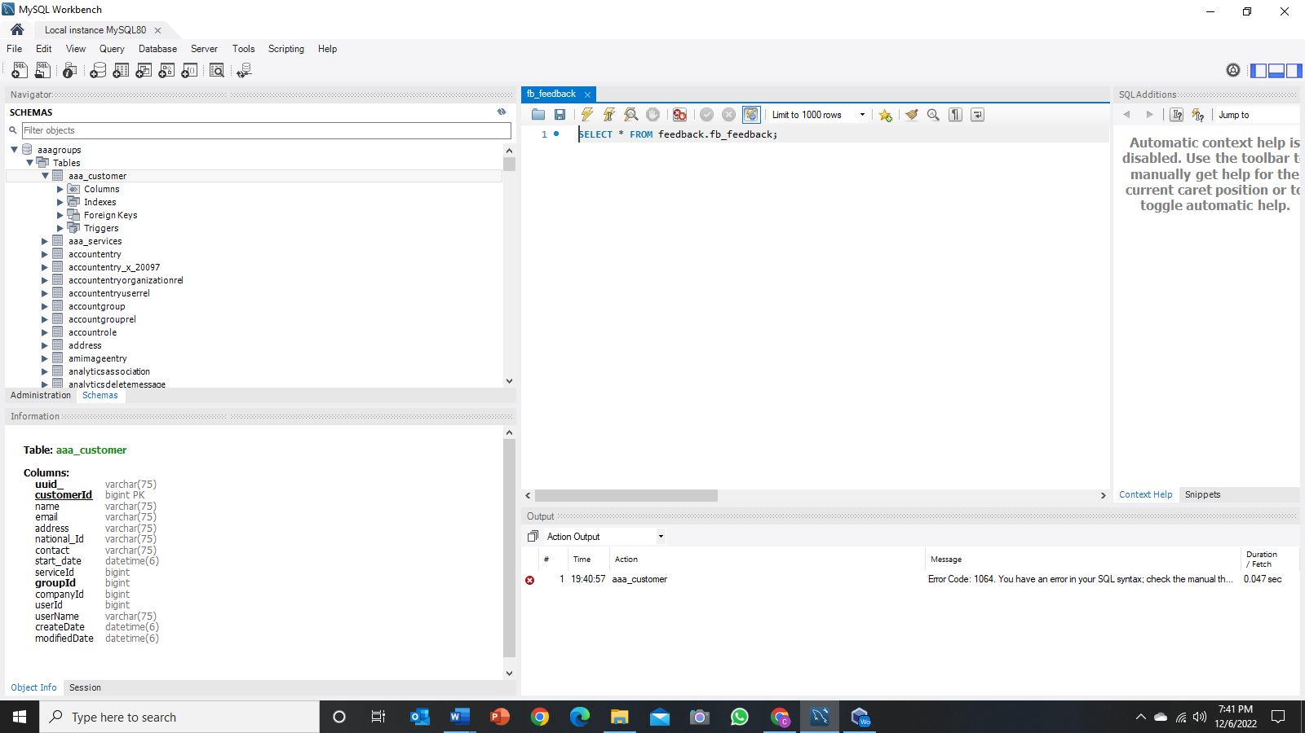**MySQL Workbench –** To create a database

Figure 2:Screenshot of MySQL Workbench

* 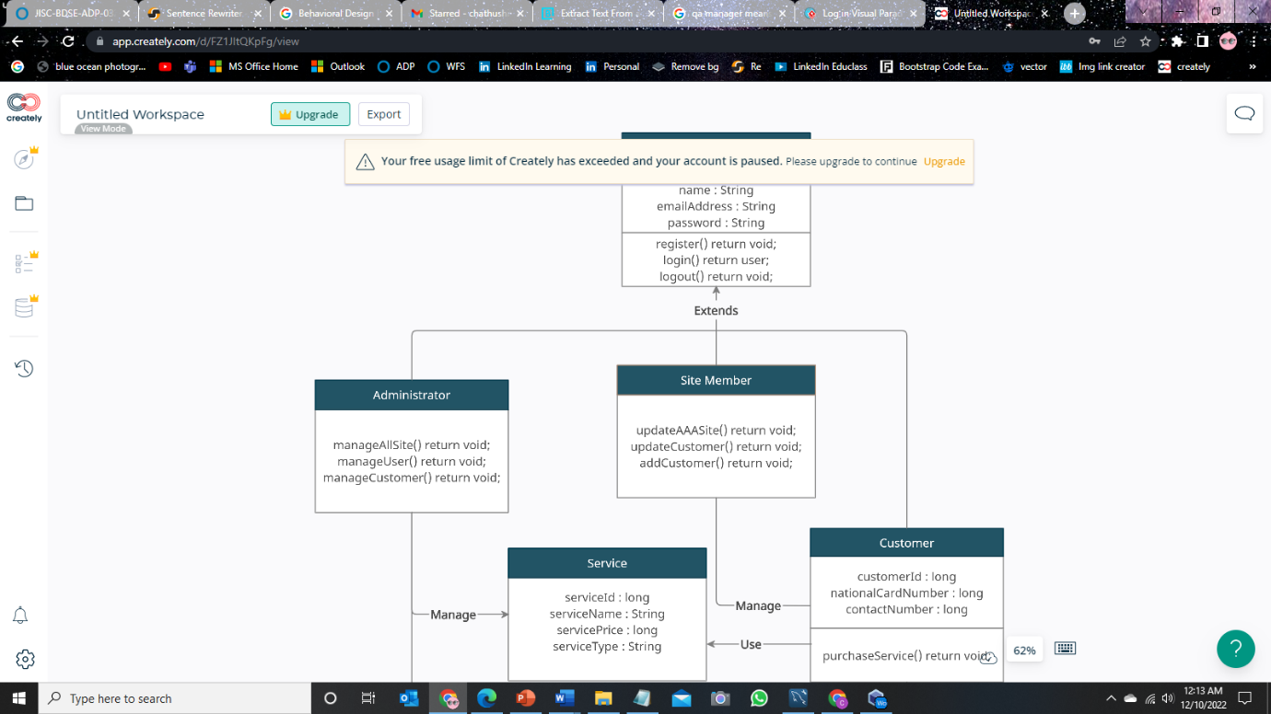**creately.com –** To create UML Diagrams

Figure 3:Screenshot of creately.com

1. **Project Requirements Specifications**
   1. **Project Scope**

There are two types of users in this portal. They are,

1. Administrator
2. Site Member (Staff)

Administrator should be able to perform the following functions in the portal,

1. Manage all of the site contents and pages.
2. Update the theme and layout.
3. Manage the customer data portlet and control permission.
4. Manage all user (Site Member and Customer) roles and permission

Site Member should be able to perform the following functions in the portal,

1. Update AAA company site content.
2. Add and Update the AAA’s customer data.
   1. **Functional Requirement**

The AAA website consists of the following Key pages,

1. Home Page
2. Registration Page
3. Login Page
4. Our services Page

* Domain name service page
* Shared Hosting service page
* Reseller Hosting service page
* Cloud Hosting service page
* VPS Hosting service page
* Dedicated Hosting service page
* Colocation service page

1. Contact us Page
2. About us Page
3. Terms and Conditions Page

**Task 01**

1. **Object Oriented Programming paradigm**

OOP is a programming paradigm that relies on the concept of classes and objects and Object-oriented programming (OOP) is a computer programming model that puts together a programming plan around data, or objects, instead of capabilities and rationale. An object can be characterized as a data field that has interesting attributes and behaviour.

OOP focuses on developers' desired items to manipulate instead of the rationale expected to manipulate them. This way to deal with writing computer programs is appropriate for programs that are enormous, complex, and effectively refreshed or kept up with. This incorporates programs for manufacturing and design, as well as mobile applications; for instance, OOP can be utilized for manufacturing system simulation software.

The association of an object-oriented program additionally makes the strategy advantageous to cooperative turn of events, where projects are separated into groups. Extra advantages of OOP include code reusability, scalability, and efficiency.

The important features of object–oriented programming are –

* OOP is faster and easier to execute
* Bottom–up approach in program design
* Programs organized around objects, grouped in classes
* Focus on data with methods to operate upon object’s data
* Interaction between objects through functions
* Reusability of design through creation of new classes by adding features to existing classes
  1. **Characteristics of the Object-Oriented Programming Paradigm**
     1. **Class**

A class is a user-defined plan or prototype that creates objects. It represents a set of properties or systems which might be not unusual to all items of a type. A class description includes two matters:

1. Attribute or member variables
2. Implementations of behavior or member functions

A class declaration consists of:

1. **Modifiers:** These can be public or default access.
2. **Class name**: Initial letter.
3. **Superclass**: A class can only extend (subclass) one parent.
4. **Interfaces**: A class can implement more than one interface.
5. 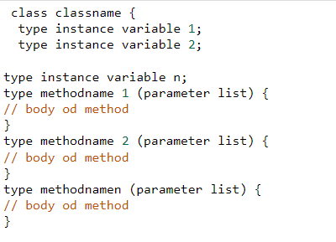**Body**: Body surrounded by braces, { }.

Figure 4:Example for OOP Concept - Class

* + 1. **Object**

Whether they were written in Java or another language, object are always called instances of a class. They exhibit states and actions. Those objects usually have real-world counterparts, or actual beings. As a result, they are additionally known as global runtime entities. These are independent and include the techniques and attributes that offer the facts its software. Physical matters and logical data can both be objects. It occupies some memory space and consists of addresses. A dog, a chair, a tree, someone, a college, and many others. Are some instances of objects.

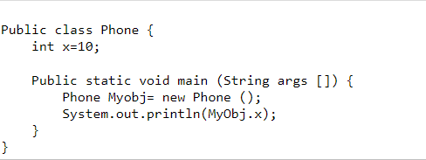We've created a class known as phone, we specify the class name followed through the object name, and we use the key-word new.

Figure 5:Example for OOP Concept - Object

* + 1. **Methods**

A Java method is a collection of statements or a series of lines of code used to carry out an operation or activity. this could be used repeatedly and is used to acquire code reuse. It also gives easy customization and readable code. simplest when we call or invoke a method does it actually run. Java has sorts of methods: consumer-defined and predefined. methods which might be predefined have previously been laid out in Java class libraries. A user-defined method is one which became created by way of the user or the programmer. The requirements can be modified for user-defined methods.

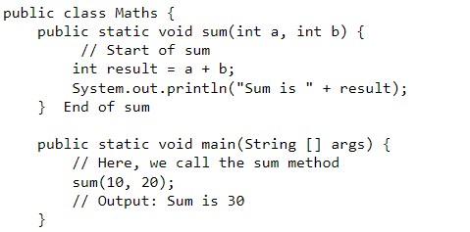

Figure 6:Example for OOP Concept - Methods

* + 1. **Encapsulation**

(Binding code and data together in a single unit)

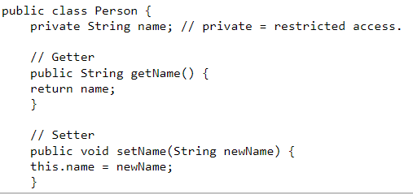Encapsulation, often known as OOP Encapsulation, is the process of grouping together methods that operate on data and data itself in object-oriented computer programming (OOP) languages. Encapsulation is widely used in the form of classes in several programming languages. A class is a structure for program code that enables programmers to design objects with variables (data) and behaviours (functions or methods). In computer science, encapsulation can be seen in the form of classes, which are collections of data and methods

Figure 7:Example for OOP Concept - Encapsulation

* + 1. **Polymorphism**

(One task is performed differently)

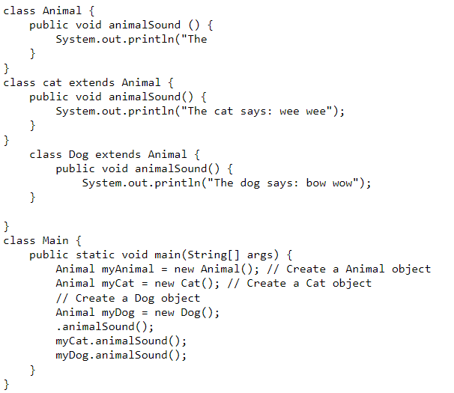One of the fundamental ideas of object-oriented programming (OOP), polymorphism addresses circumstances where something happens in a variety of ways. It refers to the idea in computer science that you can access objects of many types through the same interface. Each type may offer a unique, autonomous implementation of this interface.

Figure 8:Example for OOP Concept - Polymorphism

* + 1. **Constructors/ Destructors**

In Java, when we make an object of the class it consumes some space in the memory (heap). On the off chance that we don't delete these objects, it stays in the memory and consumes superfluous space that isn't upstanding on the part of programming. To determine this issue, we utilize the destructor. In this section, we will examine the alternate option to the destructor in Java. Likewise, we will likewise figure out how to utilize the finalize () technique as a destructor.

The destructor is something opposite to the constructor. The constructor is utilized to instate objects while the destructor is utilized to delete or destroy the item that delivers the asset involved by the object

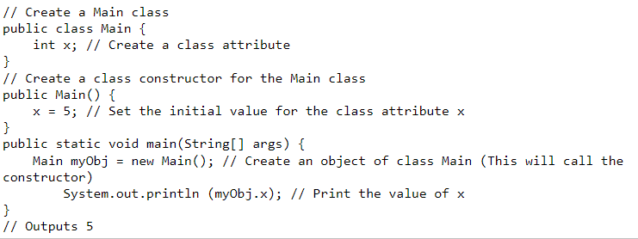

Figure 9:Example for OOP Concept - Construcators

* + 1. **Abstract**

(Hiding internal details and showing just the functionality to the user)

Reflection is the most common way of removing or eliminating qualities from something to lessen it to a bunch of fundamental qualities. In object-oriented programming, reflection is one of three focal standards Through the course of abstraction, a developer conceals everything except the significant information about an item to lessen intricacy and increment proficiency. Similarly, that reflection at times works in craftsmanship, the item that remains is a portrayal of the first, with undesirable detail discarded. The subsequent item itself can be alluded to as an abstraction, meaning a named element comprised of chosen credits and conduct well defined for a specific use of the starting substance. Abstraction is connected with both encapsulation and data hiding.

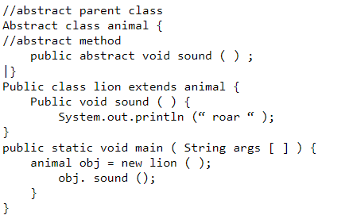

Figure 10:Example for OOP Concept - Abstract

* + 1. **Interface**

A totally abstract class is what an interface is. It consists of several abstract techniques (methods without a body). In Java, an interface is created with the interface keyword.

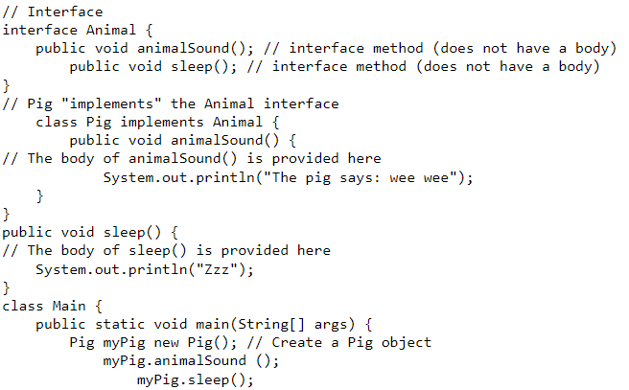

Figure 11:Example for OOP Concept - Interface

* + 1. **Differences between abstract classes and interfaces**

|  |  |
| --- | --- |
| Abstract class | Interface |
| Can have abstract and non-abstract methods | Can have only abstract methods |
| Does not support multiple inheritances | Support multiple inheritances |
| Can have final, non-final, and non-static variables | Only static and final variables |
| Can provide the implementation of interfaces | Cannot provide the implementation of abstract class |
| The abstract keyword is used to declare abstract class | The interface keyword is used to declare interface |

* 1. **Class Relationships using UML diagrams**

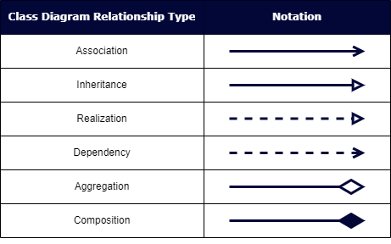Relationships in UML are used to represent a connection among structural, behavioral, or grouping matters. it is also known as a hyperlink that describes how or extra matters can relate to each other at some point of the execution of a system. sort of UML relationship are Inheritance, realization, Dependency, Aggregation and Composition.

* + 1. **Inheritance**

Inheritance is an important concept of the Unified Modelling Language (UML) and is used within the layout of classes and the modelling of class diagrams. a category includes a set of attributes and methods that determine the state and behaviour of its instances

This class diagram contains three subclasses: GoldFish, Carp and Barb one superclass: Fish. Each subclass is connected to the Fish superclass with an inheritance relationship.

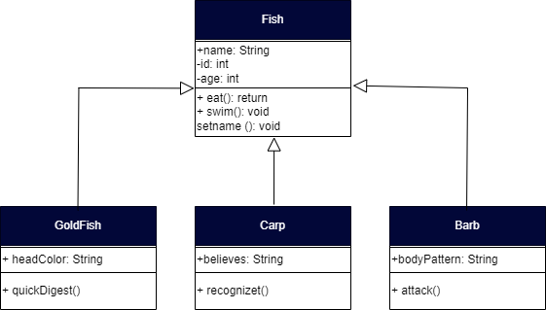

Figure 12:Example for Inheritance

* + 1. **Realization**

In UML modelling, a realization relationship is a courting between model elements, in which one version element (the consumer) realizes the behaviour that the alternative version detail (the supplier) specifies. numerous clients can understand the conduct of a single provider.

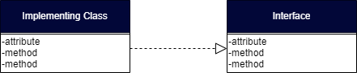

Figure 13:Example for Realization

* + 1. **Dependency**

In UML, a dependency relationship is a relationship in which one element, the consumer, uses or relies upon some other element, the supplier. you may use dependency relationships in class diagrams, component diagrams, deployment diagrams, and use-case diagrams to suggest that 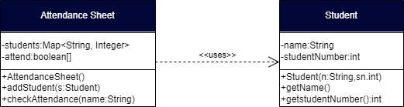exchange to the provider might require a trade to the purchaser

Figure 14:Example for Dependency

* + 1. **Aggregation**

In UML models, an aggregation relationship shows a classification as part of or subordinate to some other classifier. An aggregation is a unique sort of association in which objects are assembled or configuredcollectively to create an extra-complicated object

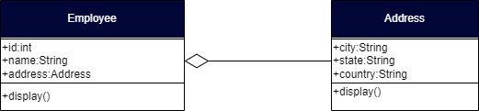

Figure 15:Example for Aggregation

* + 1. **Composition**

A composition in the Unified Modelling Language (UML) is a special case of association that describes a relationship between a whole and its existential elements. placed surely, in a composition, a part can by no means be large than the whole.

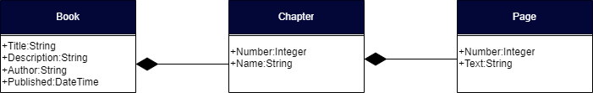

Figure 16:Example for composition

* 1. **Class relationships which are used in project scenario.**

|  |  |
| --- | --- |
| **Class Relationship type** | **Examin** |
| **Composition** | Because clients and the service class have a "strong one-to-one" relationship, when the service class changes something, it also affects the clients. Establishing a relationship between objects. |
| **Inheritance** | The Admin, Site Member, and Server classes all descend from the User class, a new superclass with shared variables and functions. Code reuse is possible. |
| **Association** | The relationship between the admin and the clients as the admin can only manage the servers and site members. Site members can only handle clients, and the admin and site member, as well as site member and client classes are unimodal. |

1. **Suitable design patterns based on the AAA Portlet**
   1. **Creational design pattern**

In software engineering, creational design patterns are design patterns that cope with object introduction mechanisms, trying to create objects in a way suitable to the state of affairs. The basic form of item creation could result in design problems or in brought complexity to the design. Creational design patterns are concerned with the manner of making objects. those design patterns are used while a decision ought to be made at the time of instantiation of a class

|  |  |
| --- | --- |
| Factory Method Pattern | Define an interface or abstract class for developing an object however permit the subclasses to decide which class to instantiate |
| Abstract Factory Pattern | Define an interface or abstract class for creating families of related objects however without specifying their concrete sub-classes. |
| Singleton Pattern | Define a class that has the most effective example and presents a worldwide point of access to it |
| Prototype Pattern | Cloning of a current object as opposed to creating a new one can also be custom designed according to the requirement. |
| Builder Pattern | Construct a complex object from simple objects the usage of step-by means of-step approach |

* + 1. **Suitable creational design pattern for “AAA Portlet”**

For this, the factory method pattern and the constructor design pattern are used. Create an interface or summary class to create objects there, or permit subclasses decide which class to apply. The factory method pattern may be used to pick the kind of item to create by using sub classing. This promotes unfastened coupling by using doing away with the want to link application-specific classes in code. that is, it creates an object little by little. This is, it is often used within the serialization of a complicated object, in instances where an object cannot be created in a single step.

* 1. **Structural design pattern**

Structural design pattern is a blueprint of the way one of a kind objects and classes are mixed collectively to form a bigger structure for reaching multiple goals altogether. The patterns in structural designs show how specific portions of a system can be combinedcollectively in an extensible and bendy way

|  |  |
| --- | --- |
| Adapter Pattern | Allows in converting the interface of a class into any other interface depending at the consumer's requirements |
| Bridge Pattern | To split the implementation element from the abstraction component in order that the abstraction and implementation of a class can range independently |
| Composite Pattern | The client is able to perform objects which may additionally or won't represent its hierarchy |
| Decorator Pattern | Can add or remove object functionality without converting the function or external look of the object |
| Façade Pattern | Offer a simplified interface to a set of interfaces of a subsystem for hiding its complexity of subsystem from the customer |
| Flyweight Pattern | To reuse comparable forms of existing objects with the aid of storing and developing new objects while similar objects are not observed |
| Proxy Pattern | Provide a placeholder or a surrogate object to control access to the authentic object |

* + 1. **Suitable structural design pattern for “AAA Portlet”**

Here adapter pattern and facade pattern are used. While the use of a service with classes that have special interfaces, or extra matters that have been previously incompatible with interfaces add capability that may be reused and interacted with every other at the request of the client. The facade pattern specifies a excessive-level interface that makes the subsystem easy to use. That is, gives an interface to a fixed of interfaces. Util protects the consumer from subsystem additives and loosely connects subsystems and clients.

* 1. **Behavioral design pattern**

Behavioral design patterns are involved with the interaction and duty of objects. In those design patterns, the interplay between the objects ought to be in this sort of manner that they are able to easily communicate to every different and still need to be loosely coupled. This means the implementation and the client ought to be loosely coupled so as to keep away from hard coding and dependencies.

**There are 12 types of behavioral design patterns:**

* Chain of Responsibility Pattern
* Command Pattern
* Interpreter Pattern
* Iterator Pattern
* Mediator Pattern
* Memento Pattern
* Observer Pattern
* State Pattern
* Strategy Pattern
* Template Pattern
* Visitor Pattern
* Null Object
  1. **Suitable behavioral design pattern for “AAA Portlet”**
* **Template Pattern**

Because we use many classes, most of which percentage exceedingly similar code, we should create a template for a summary class with the majority of the functions predefined, after which create every other class with moderate modification in accordance with the preferred final results.

* **Observer Pattern**

Because the portlet itself contains a one-to-many relationship, as an example one patron should have multiple providers, that’s where the observer pattern should come in handy to keep the music of the state of the object within the portlet

1. **How the object-orientated paradigm and its key principle are identified in each of the design patterns.**

**OOP (object orientated Paradigm)**

The problem–solving method utilized by the OOP is entirely distinctive. Because it concentrates parts of the machine instead of being solved. In the real world, we can use objects like automobiles and cats are excellent examples. Due to the fact that OOP is a programming technique or philosophy that divides code into the object and their connections. Layout styles will provide attempted-and-authentic methods of making sorts or objects to deal with a certain problem in a software

* 1. **Encapsulation**

(Connection between encapsulation and design pattern)

Encapsulation is accomplished whilst each object keeps its state private, internal a class. other items don’t have direct get entry to to this state. as a substitute, they could most effective call a list of public features — called methods. So, the object manages its own state via methods — and no different class can touch it unless explicitly allowed. in case you need to speak with the object, you ought to use the methods supplied. however (through default), you could’t exchange the state.

**Example:** There are humans and there may be a cat. They speak with each different. We need to apply encapsulation, so we encapsulate all “cat” logic into a Cat class. it can appear like this:

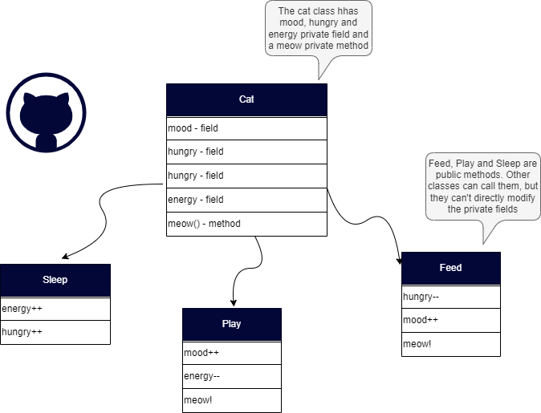

Figure 17:Example for encapsulation

(Here the “state” of the cat is the private variables *mood, hungry* and *energy*. It also has a non-public method *meow().* It could call it on every occasion it wishes, the other classes can’t inform the cat whilst to meow.

What they are able to do is defined within the public methods *sleep(),* *play()* and *feed().* Every of them modifies the inner state one way or the other and may invoke *meow().* Accordingly, the binding between the private state and public methods is made.)

* 1. **Abstraction**

(Connection between abstraction and design pattern)

Abstraction can be notion of as a natural extension of encapsulation. In object-oriented design, programs are regularly extraordinarily big. And separate objects communicate with each different load. So, maintaining a huge codebase like this for years — with changes alongside the way — is difficult. Abstraction is a concept aiming to ease this problem. Applying abstraction means that each object must simplest disclose an excessive-level mechanism for using it.

**Example:** You interact with your telephone with the aid of using only a few buttons. What’s happening below the hood? You don’t must recognise — implementation info are hidden. You only want to recognize a brief set of moves.

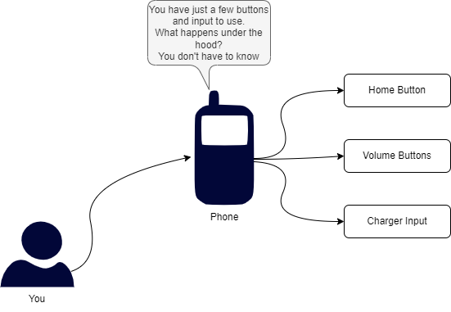

Figure 18:Example for abstraction

* 1. **Inheritance**

Inheritance saves effort and time due to the fact you do not need to rewrite the main code. Inheritance provides a clean model structure that is straightforward to understand and inheritance leads to lower development and maintenance fees. That allows the code to be reused as many times as wanted. that is, the base class is defined as soon as and as soon as it is compiled, it does not want to be redone. also saves time and effort as there's no need to rewrite the main code.

**Example:** If our program wants to manipulate public and private teachers, however also different styles of human beings like students, we are able to implement this class hierarchy. This way, every class adds most effective what it desires even as reusing common logic with parent classes.

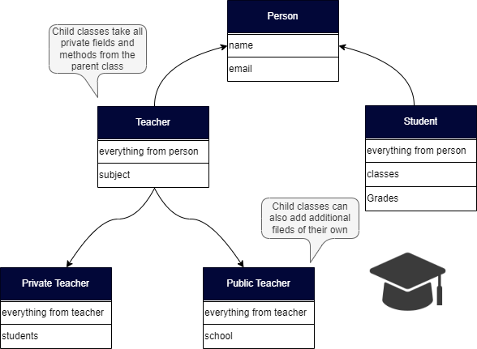

Figure 19:Example for Inheritance

* 1. **Polymorphism**

Programmer code may be reused via polymorphism and feature a single variable name for more than one data types. also reduces coupling among one of a kind functions. Also, a terrific design pattern has many classes and objects, a number of which might also share the identical call. design patterns offer efficient methods of constructing types and objects to clear up a selected example of a software. A design pattern follows this rule to distinguish among functions or objects with the equal name. Through embracing the principle of polymorphism, a design pattern can include many tasks with the same name however specific goals and parameters.

**Example:** Take a look at a sketch of geometric figures implementation. They reuse a commonplace interface for calculating surface area and perimeter:

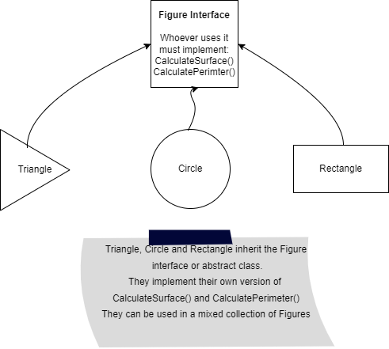

Figure 20:Example for Polymorphism

**Task 02**

1. 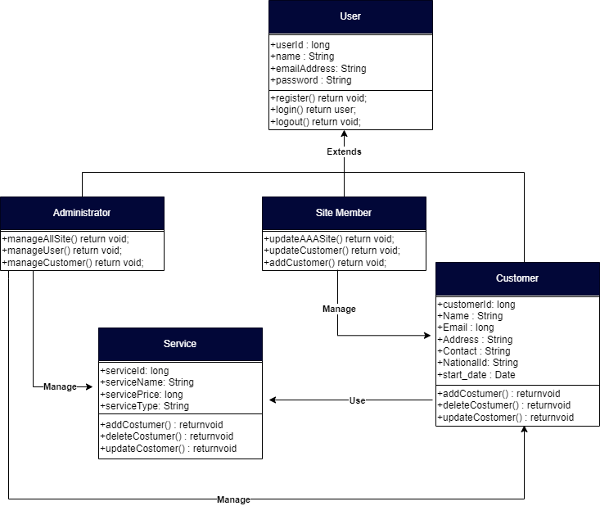**Class Diagrams showing Class-relationships**

Figure 21:Class Diagram

* 1. **Relationship between classes**

Users are divided into 2 as admin and site members. Admin can manage the customer and manage the offerings and a member of the website can manipulate the consumer. The relationship between services and clients is composition, i.e. Composition of clients. Customers exist or are created if someone wishes services. Inheritance is used for admin, website member and user classes as inheritance lets in us to put in writing applications that require fewer base and super classes. Inheritance creates a subclass which can use the methods of its superclass without rewriting the code for the

ones methods. For customer and services, composition, service, and client are associated with every other. Whenever there may be a customer which means there must be a service. Admin makes use of customer and service association; admin can manage consumer and service.

|  |  |  |  |
| --- | --- | --- | --- |
| Class | Attributes | Methods | Explanation |
| Admin |  | manageSite() manageAllUser() manageService() | A class named Admin inherits the residences of the user class and the admin can manage the web site in various project record NICF Capstone assignment the usage of Java page | 48ways. It has information control skills and internet site access. |
| Customer | Name  Email  Address  Contact  Start_date Service_Name | provideInformation() | A class that gets the attribute from the user. On the grounds that a record of a customer who purchased a service requires more particular records, numerous attributes have been introduced |
| Site Member |  | editCustomer() removeCustomer() addCustomer() addContent() editContent() removeContent() | The web page Member class inherits properties from the user class, a designation that influences both content and information approximately the customer. |

1. **Possible situations where design patterns would be beneficial**
   1. **Where should we use Design Patterns**

In the analysis and requirement gathering part in the SLDC we need to use design patterns

* 1. **Benefit of Design Patterns**

Design patterns make it less complicated to regulate software and reuse objects. It is less difficult to reuse and adjust loosely connected objects. Design styles are created the usage of a spread of tiny specialized objects. The system object acting the requested function is given useful responsibilities.

• This feature makes it easier to preserve binary compatibility with later versions.

• It is simple to create and solve future troubles.

• Designers and developers can communicate greater clearly and precisely when the use of design patterns

* **Façade Pattern**

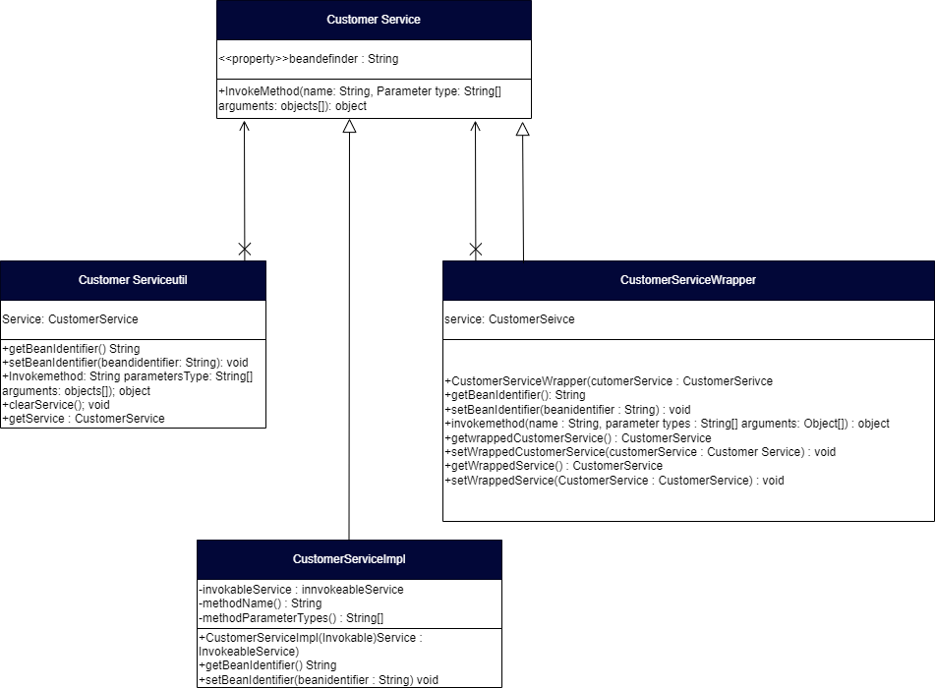

Figure 22:Example for facade pattern

* **Factory Pattern**

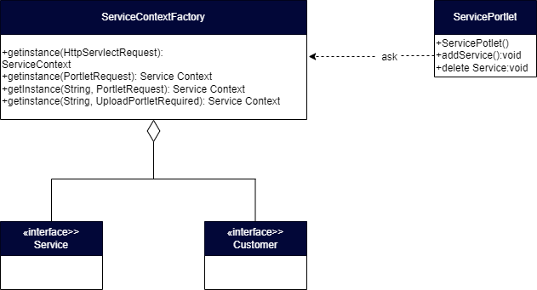

Figure 24::Example for factory pattern

* **Template pattern**

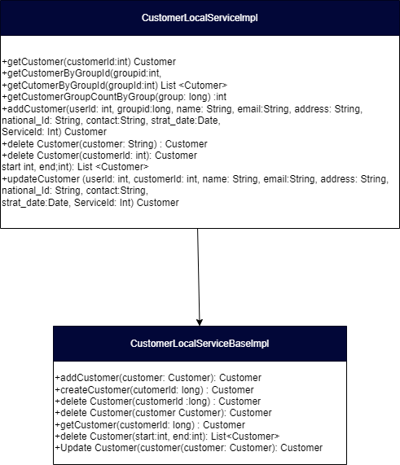

Figure 25::Example for template pattern

1. Observe how the class diagrams are reflected from a given scenario by using the UML tool

The authoring layout pattern inside the service portlet is the manufacturing unit design pattern code. The servicecontext of a service portlet obtains a service class from a servicecontextfactory. Similarly, the customer portlet employs the factory design pattern. A class diagram consists of class names and properties, as well as class hyperlinks and methods. As a result, the class diagram displays the software's actual source code. The prototype design sample code clones a current item as opposed to creating a new item as the next form of design pattern code for creation.

Customermodelimpl clones the parent class customermodel's clone() function. Customermodelimpl clones the parent class customermodel's clone() function. After analyzing the code, I quick-created a class diagram of the usage of UML tools. Due to structural design patterns. In the source code, the observer design pattern is used. The localserviceimpl class, for starters, extends and overrides the techniques of the hyper-abstract customerlocalservicebaseimpl class. The Observer pattern is the last design pattern I created, as proven in the diagram.

**Task 03**

1. Set up a project, and build an application based on derived UML class diagrams and design patterns. Provide screenshots as evidence.

* 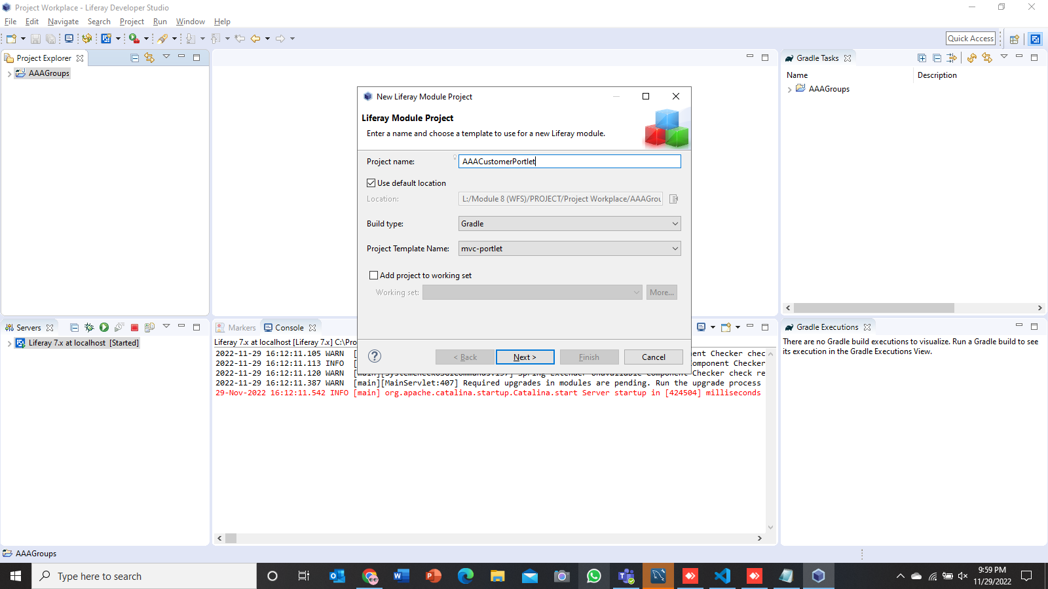Create MVC Portlet and Service Builder to manage AAA Customer’s data

Figure 26:Screenshot of project setup 1

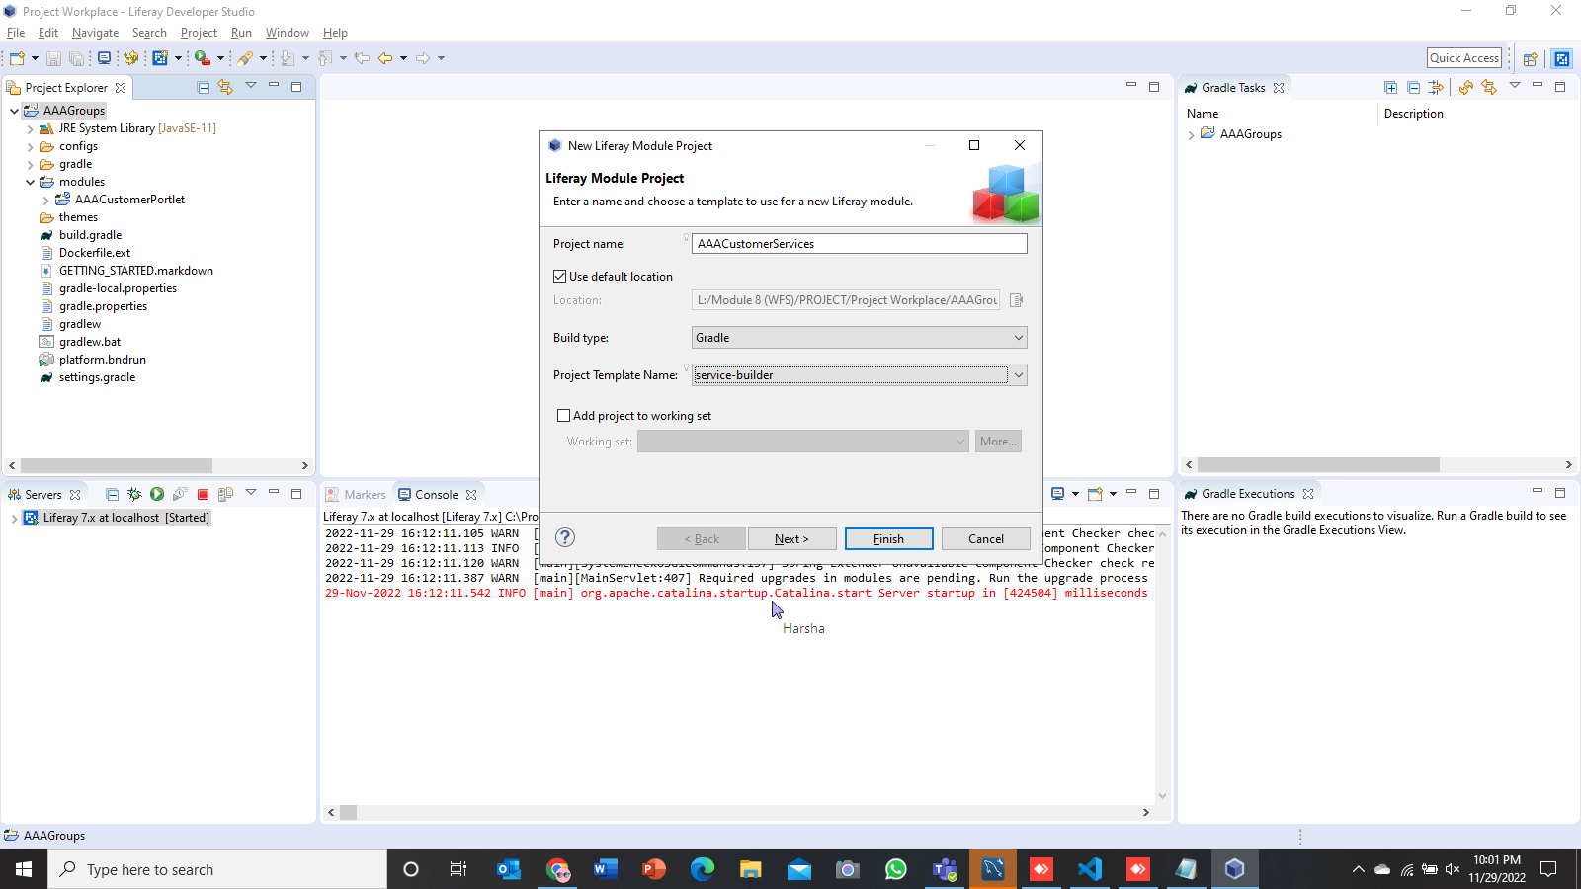

Figure 27:Screenshot of project setup 2

* 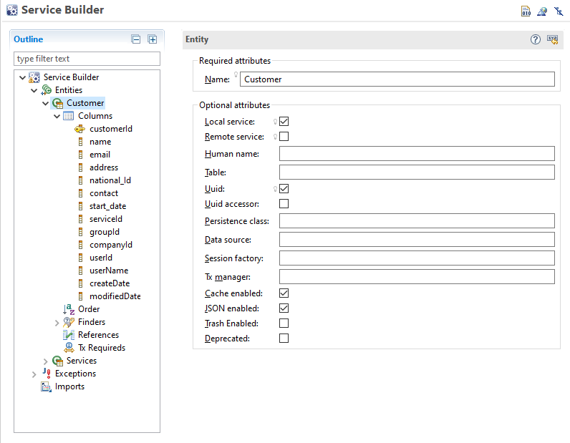Build required entities for “AAA Customer Portlet” by using service builder.

Figure 28:Screenshot of build required entities for AAA Customer Portlet

* 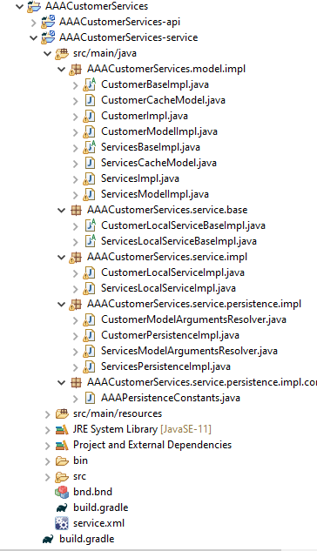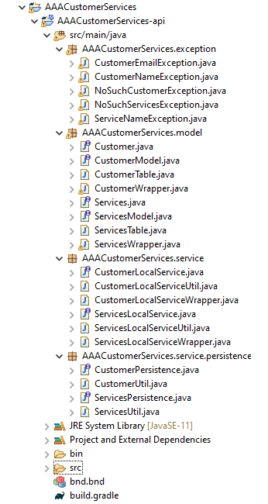Service Layer

Figure 29:Screenshot of service layer 2

Figure 30:Screenshot of service layer 1

* Service.xml

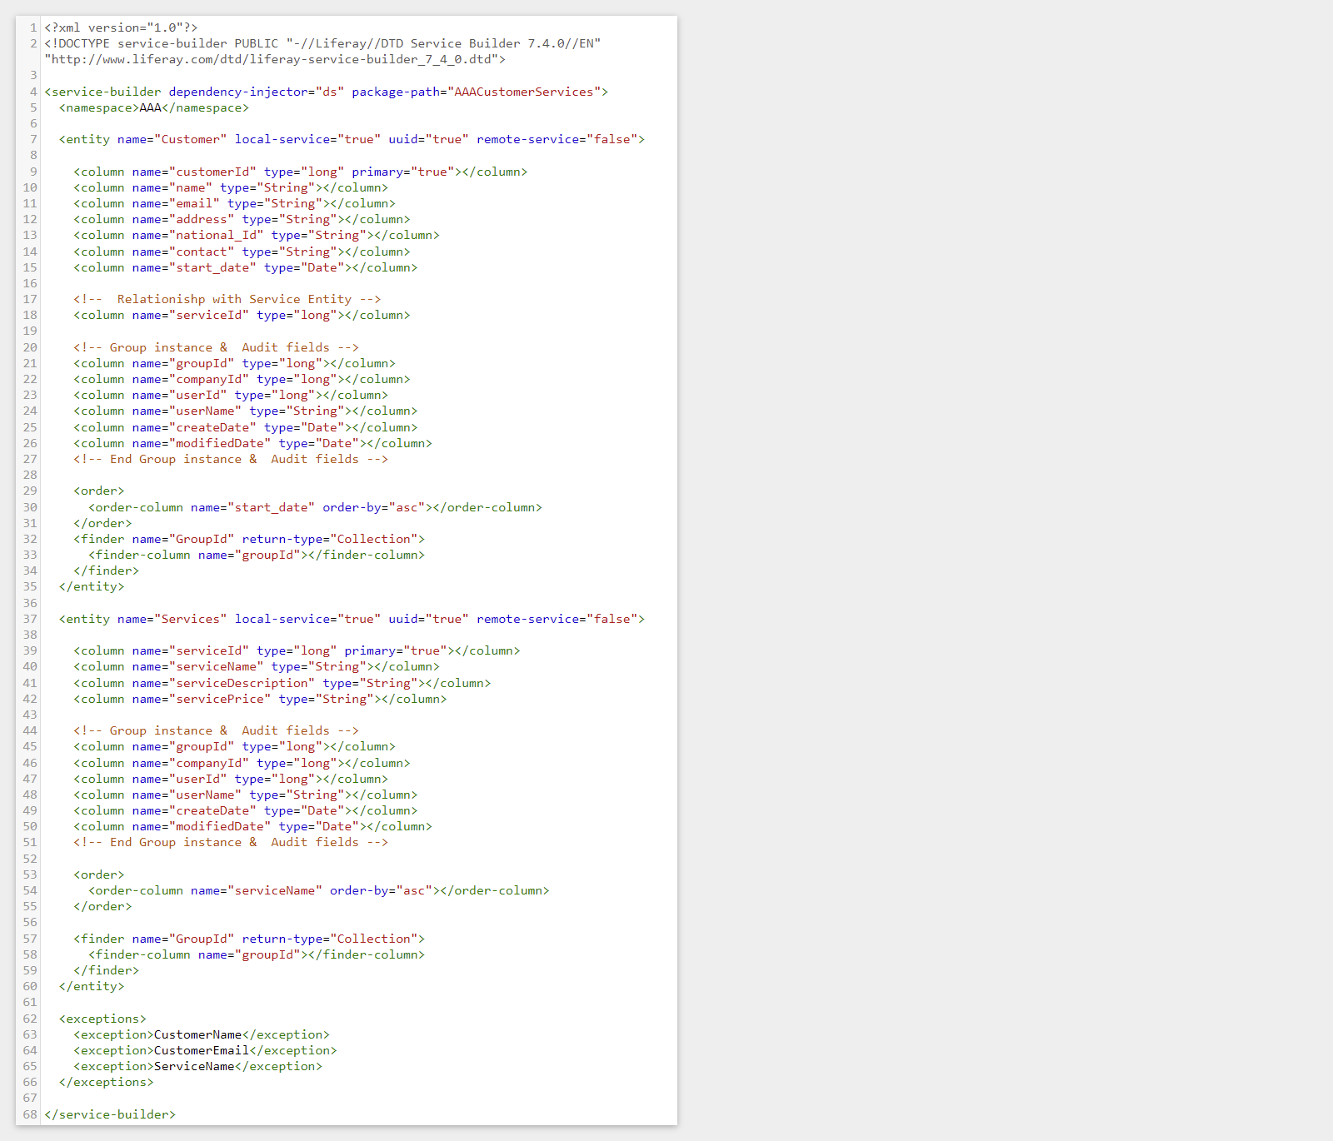

Figure 31:Screenshot of service.xml

* 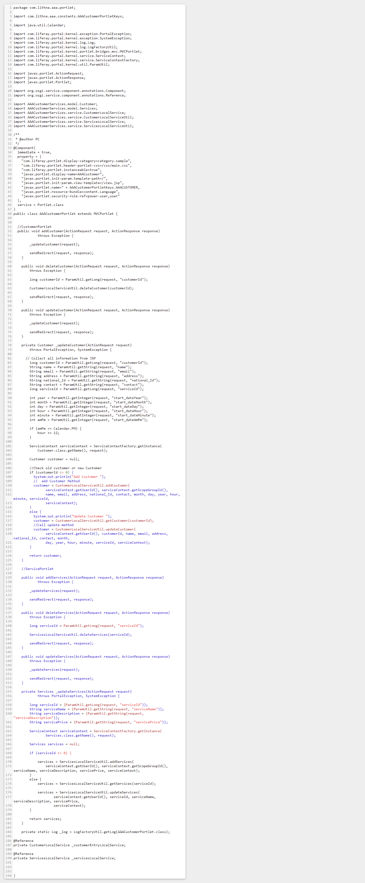Portlet Controller



Figure 32:Screenshot of Portlet Controller

* View (Jsp Files)

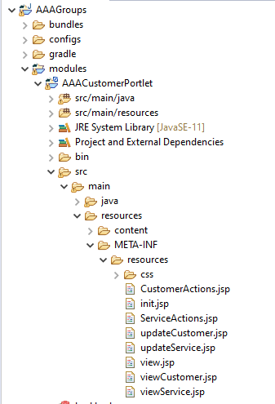

Figure 33:Screenshot of View (JSP files)

* 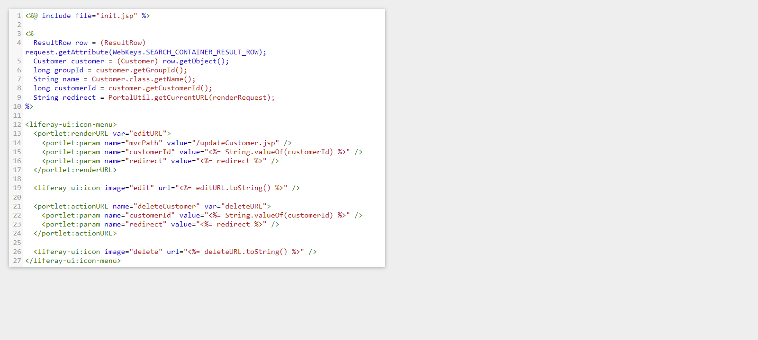CustomerAction.jsp

Figure 34:Screenshot of CutomerAction.jsp

* 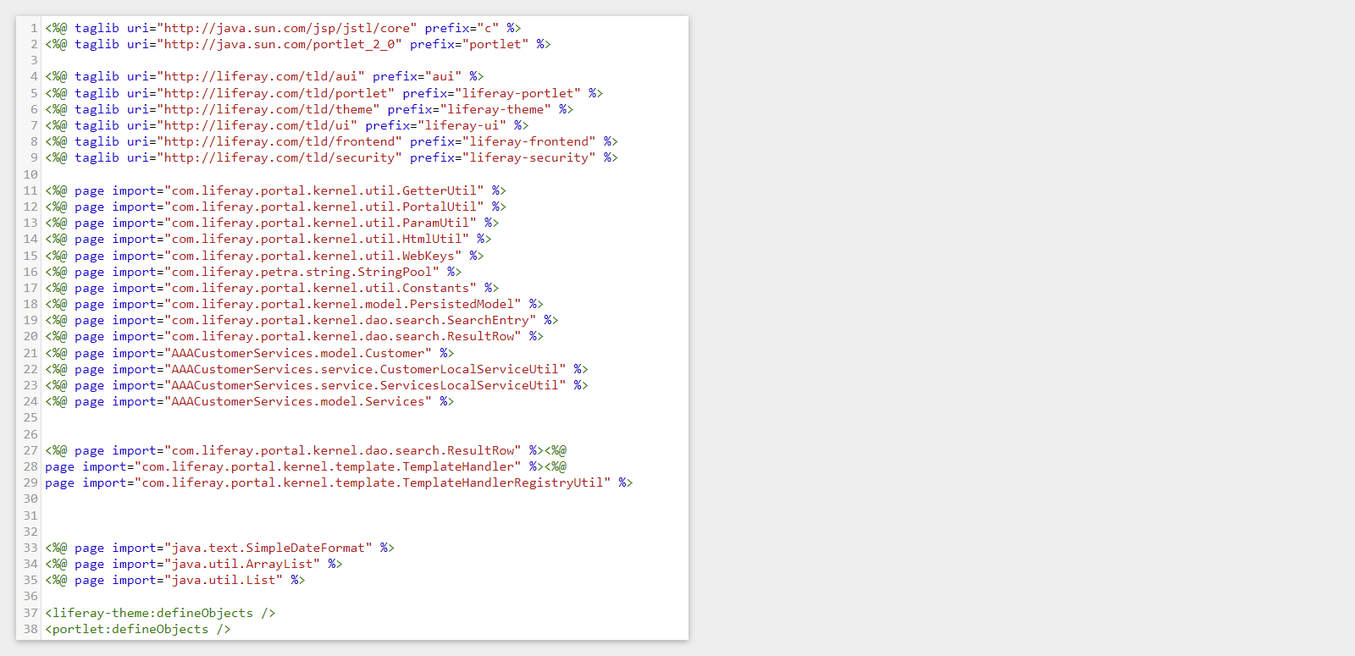Init.jsp

Figure 35:Screenshot of Init.jsp

* 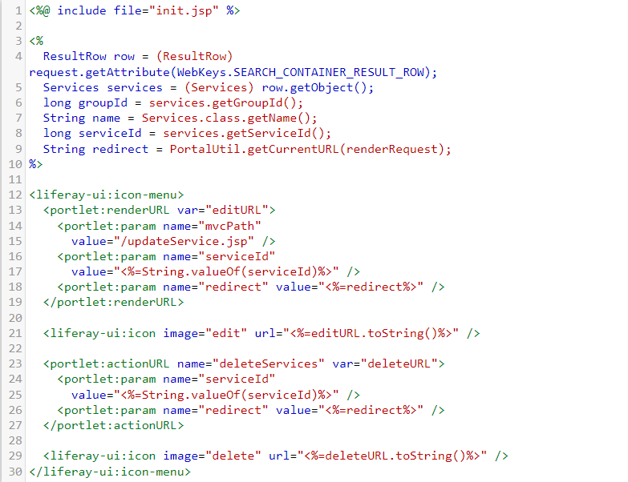ServiceAction.jsp

Figure 36:Screenshot of ServiceAction.jsp

‘

* 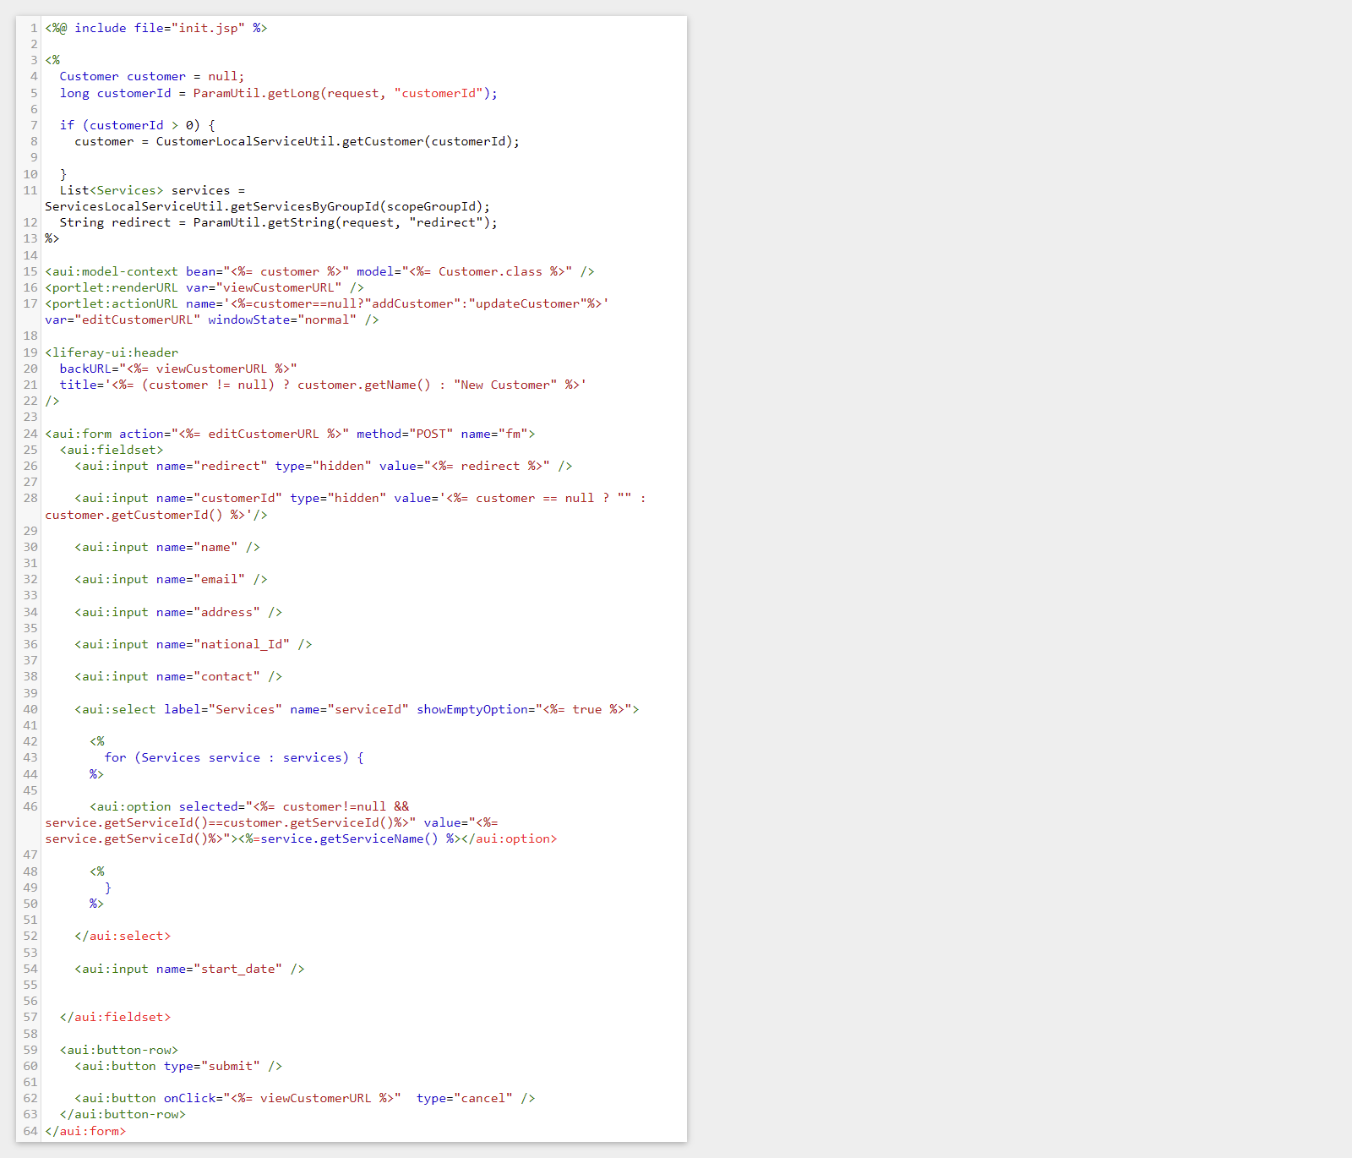updateCustomer.jsp

Figure 37:Screenshot of updateCustomer.jsp

* 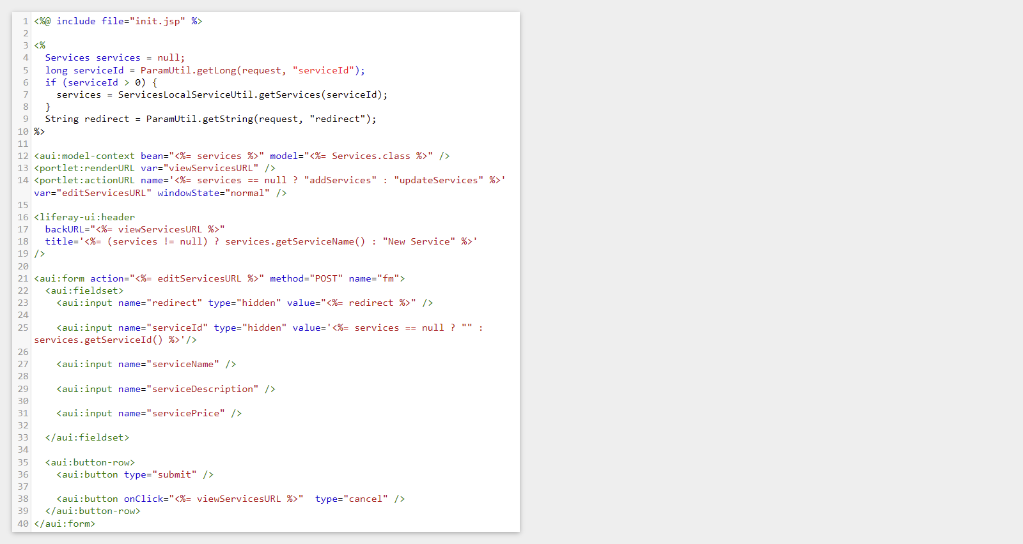updateService.jsp

Figure 38:Screenshot of updateService.jsp

* view.jsp

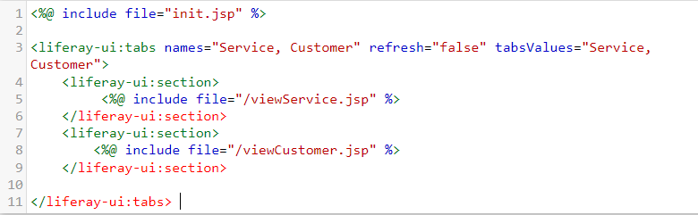

Figure 39:Screenshot of view.jsp

* 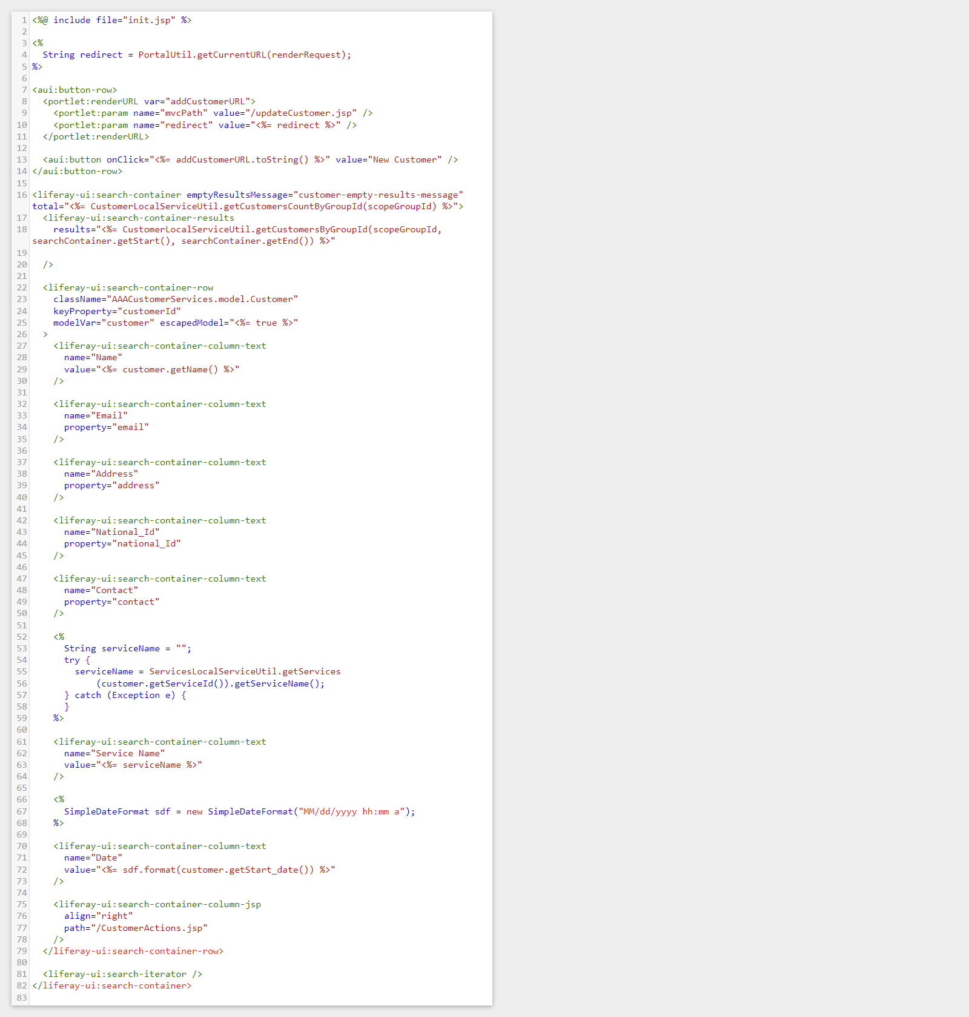viewCustomer.jsp

Figure 40:Screenshot of viewCustomer.jsp

* 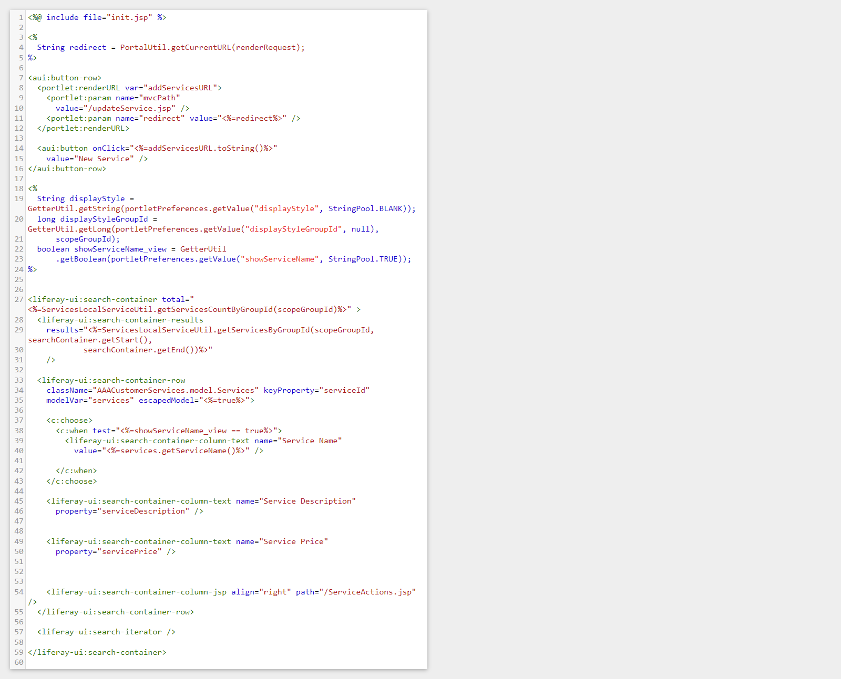viewService.jsp

Figure 41:Screenshot of viewService.jsp

* Create the Triple-A (AAA) company webpages
* 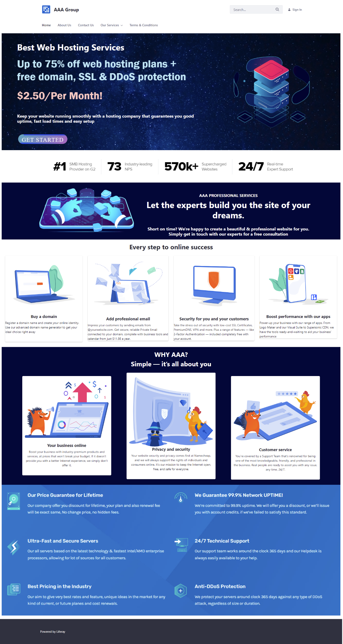Home Page

Figure 42:Screenshot of Home page

* About Us

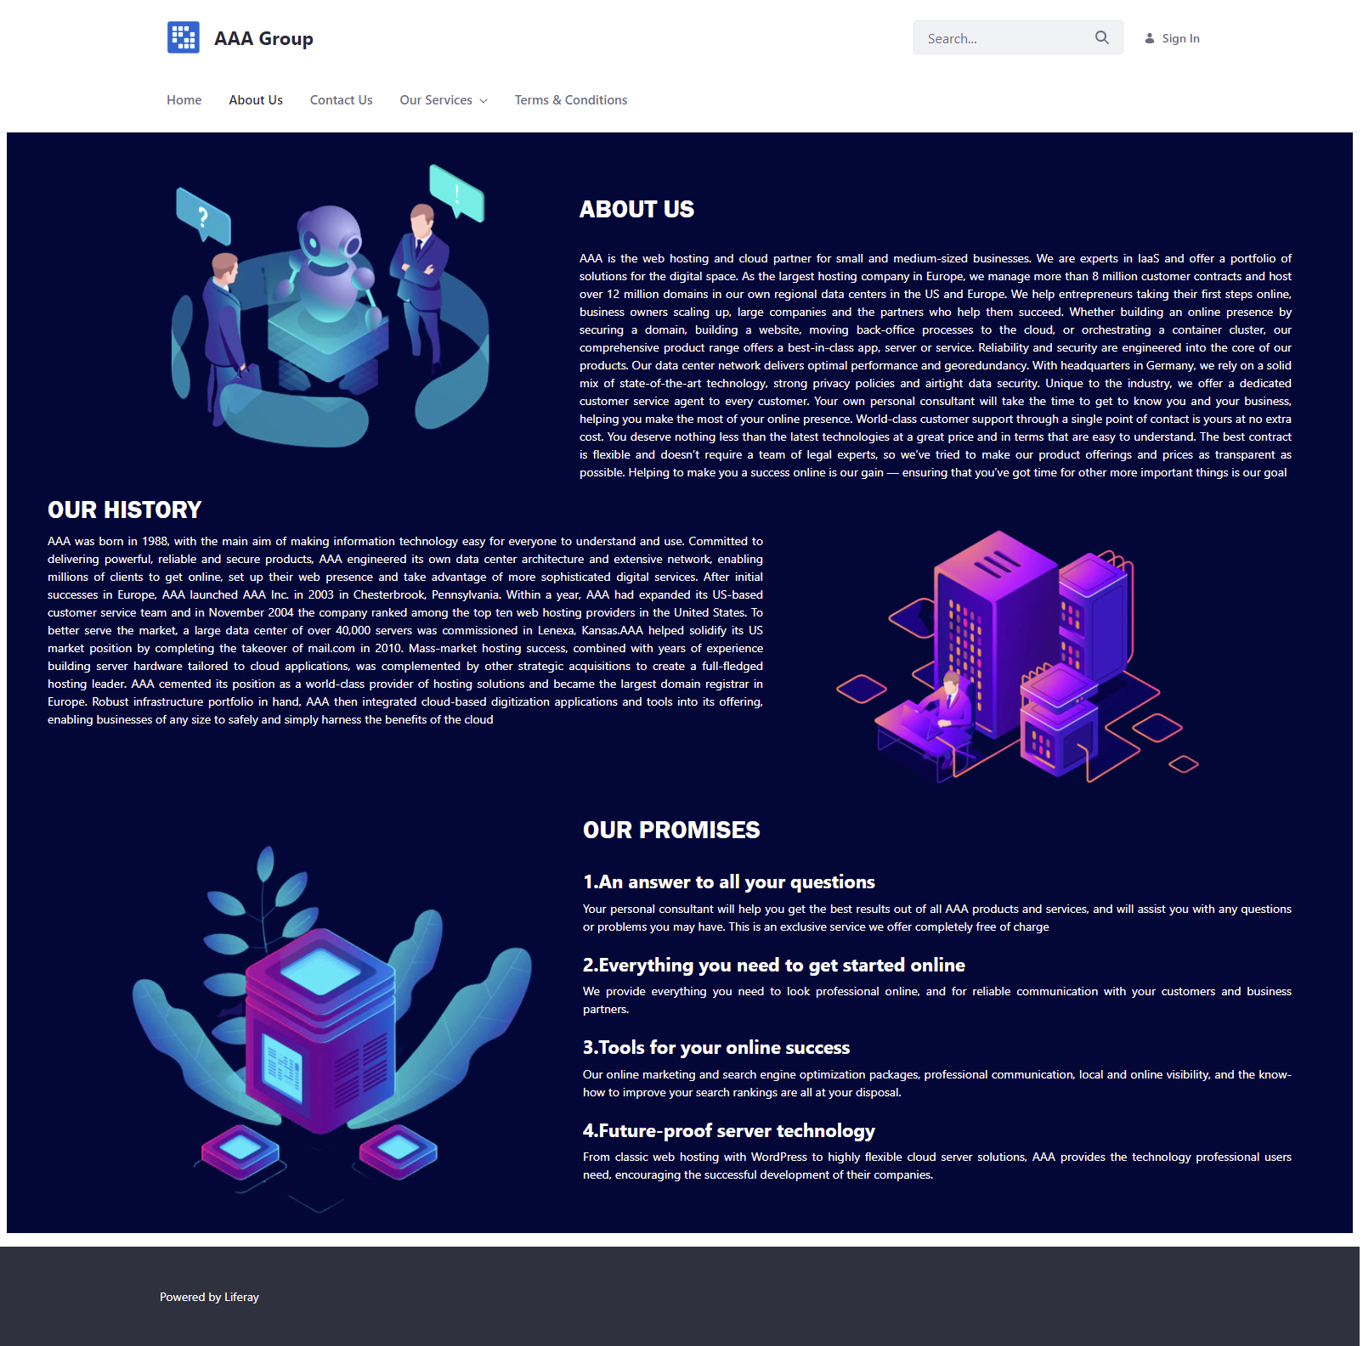

Figure 43:Screenshot of About Us page

* **Contact Us Page**

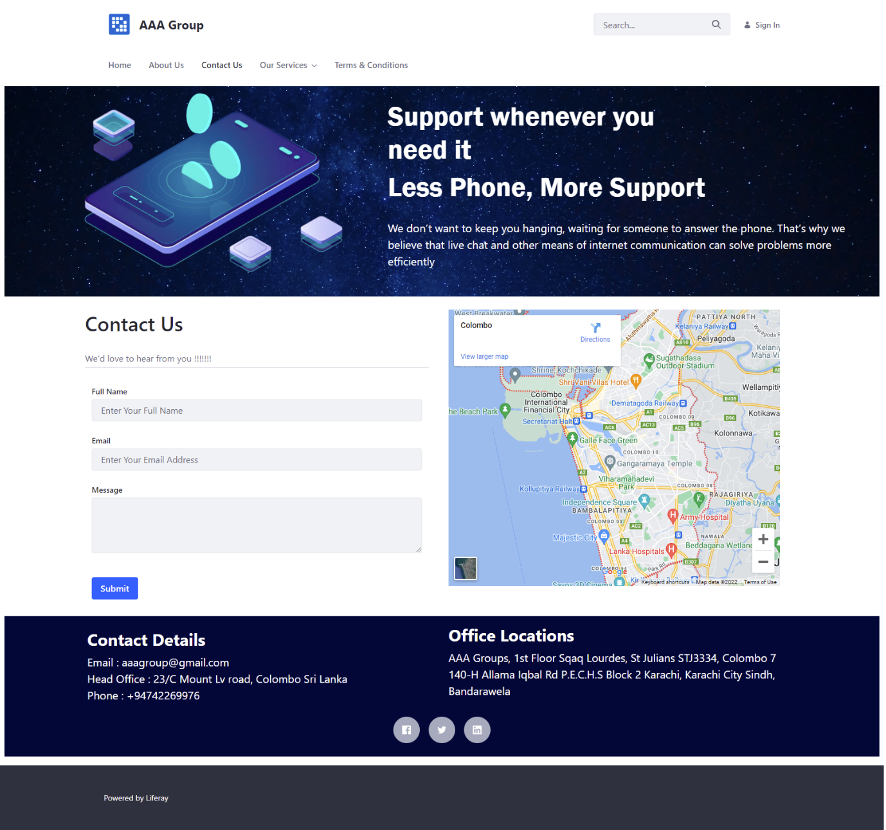

Figure 44:Screenshot of Contact us page

Figure 45:Screenshot of Contact Us Page

* **Our Services**

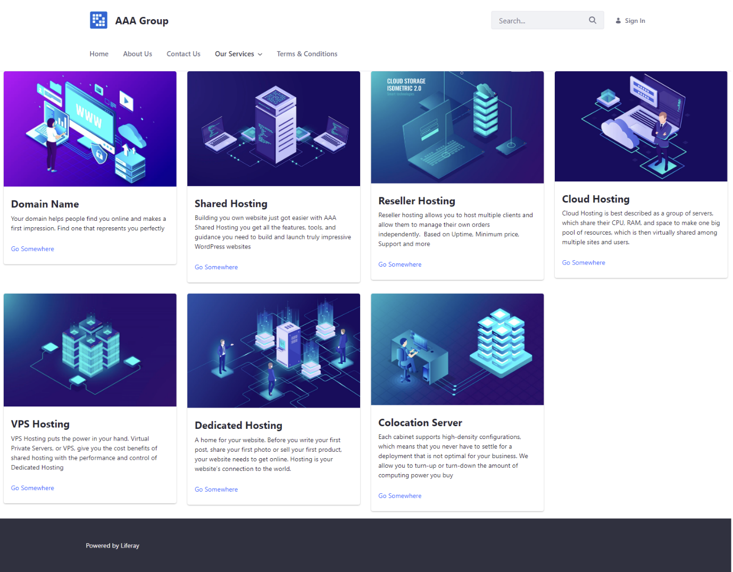

Figure 46:Screenshot of Our Services Page

Figure 47:Screenshot of Our Services Page

* **Domain Name**

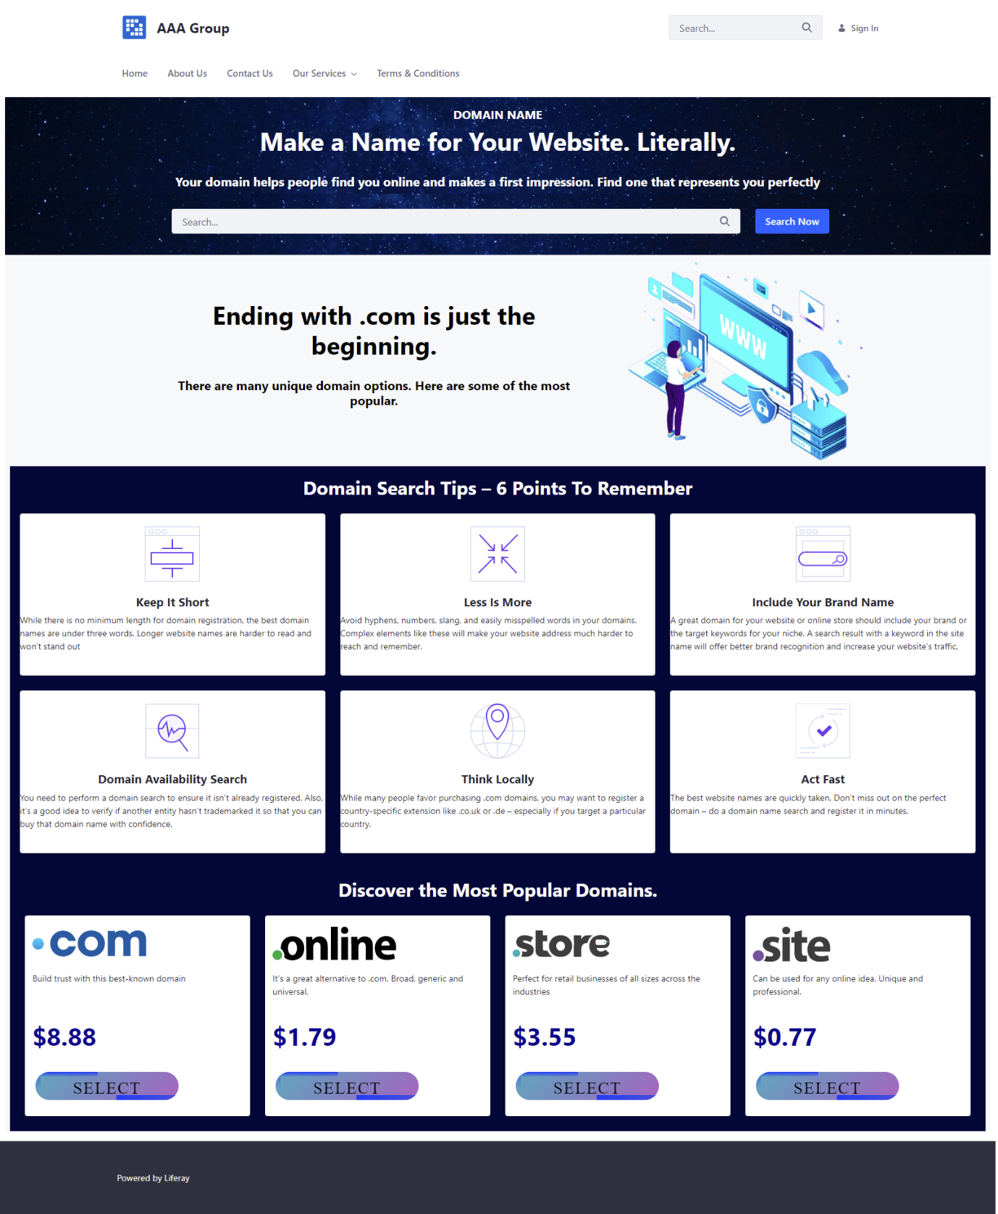

Figure 48:Screenshot of Domain Name Page

Figure 49:Screenshot of Domain Name Page

* **Shared Hosting**

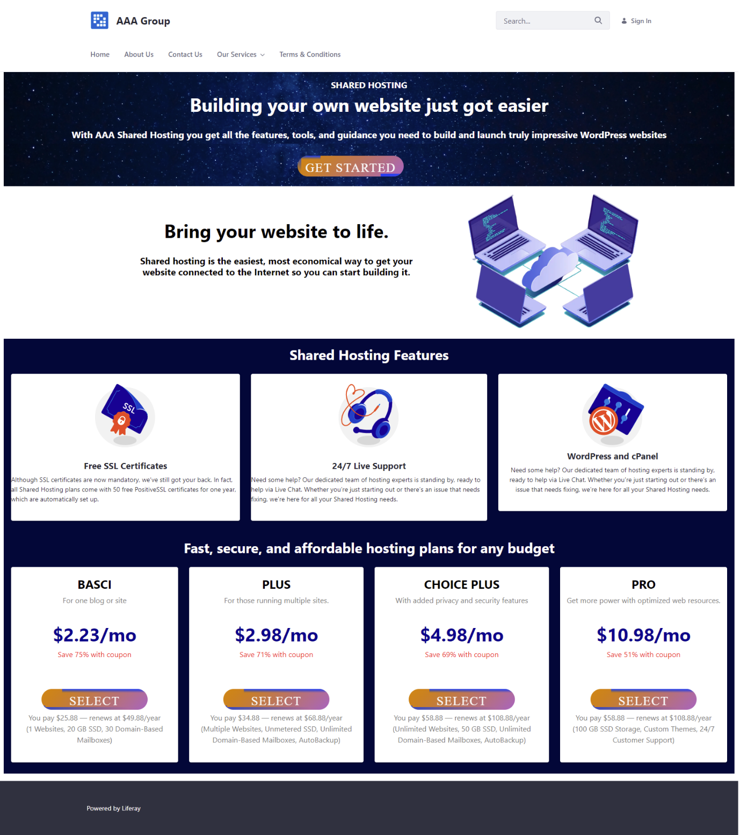

Figure 50:Screenshot of Shared Hosting

Figure 51:Screenshot of Shared Hosting Page

* **Reseller Hosting**

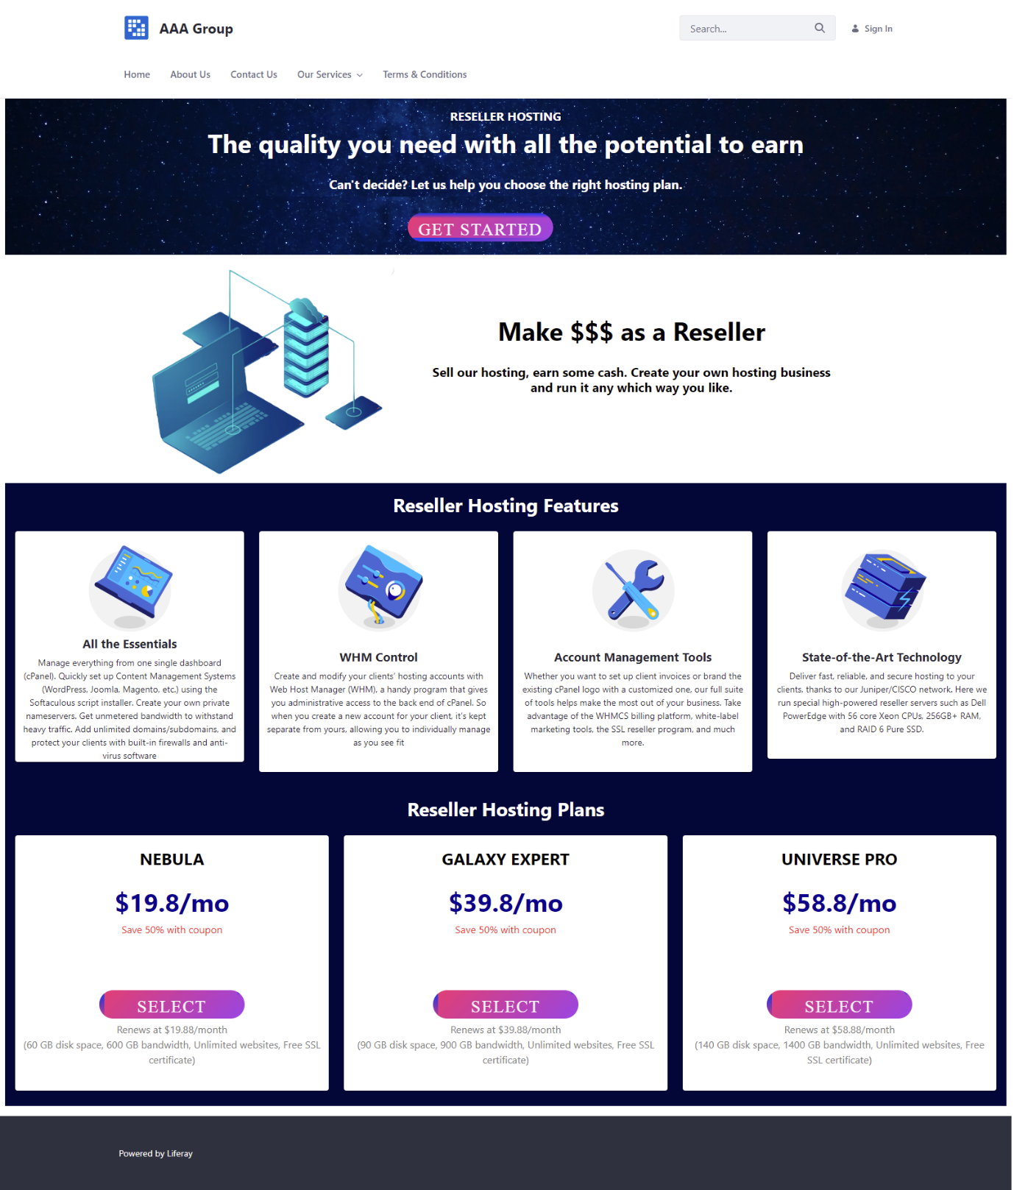

Figure 52:Screenshot of Reseller Hosting page

* **Cloud Hosting**

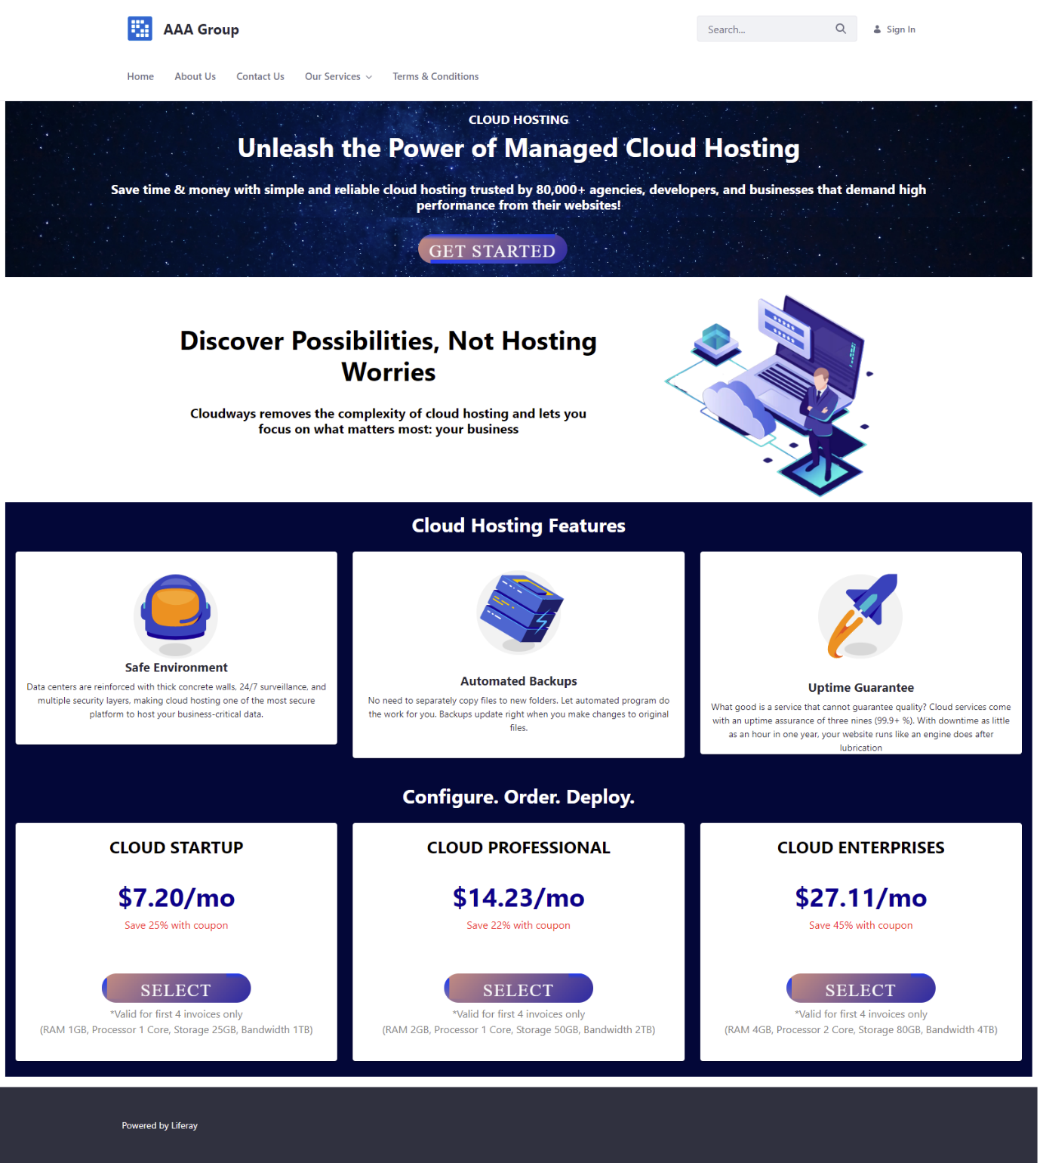

Figure 53:Screenshot of Cloud Hosting page

* **VPS Hosting**



Figure 54:Screenshot of VPS Hosting page

* **Dedicated Hosting**

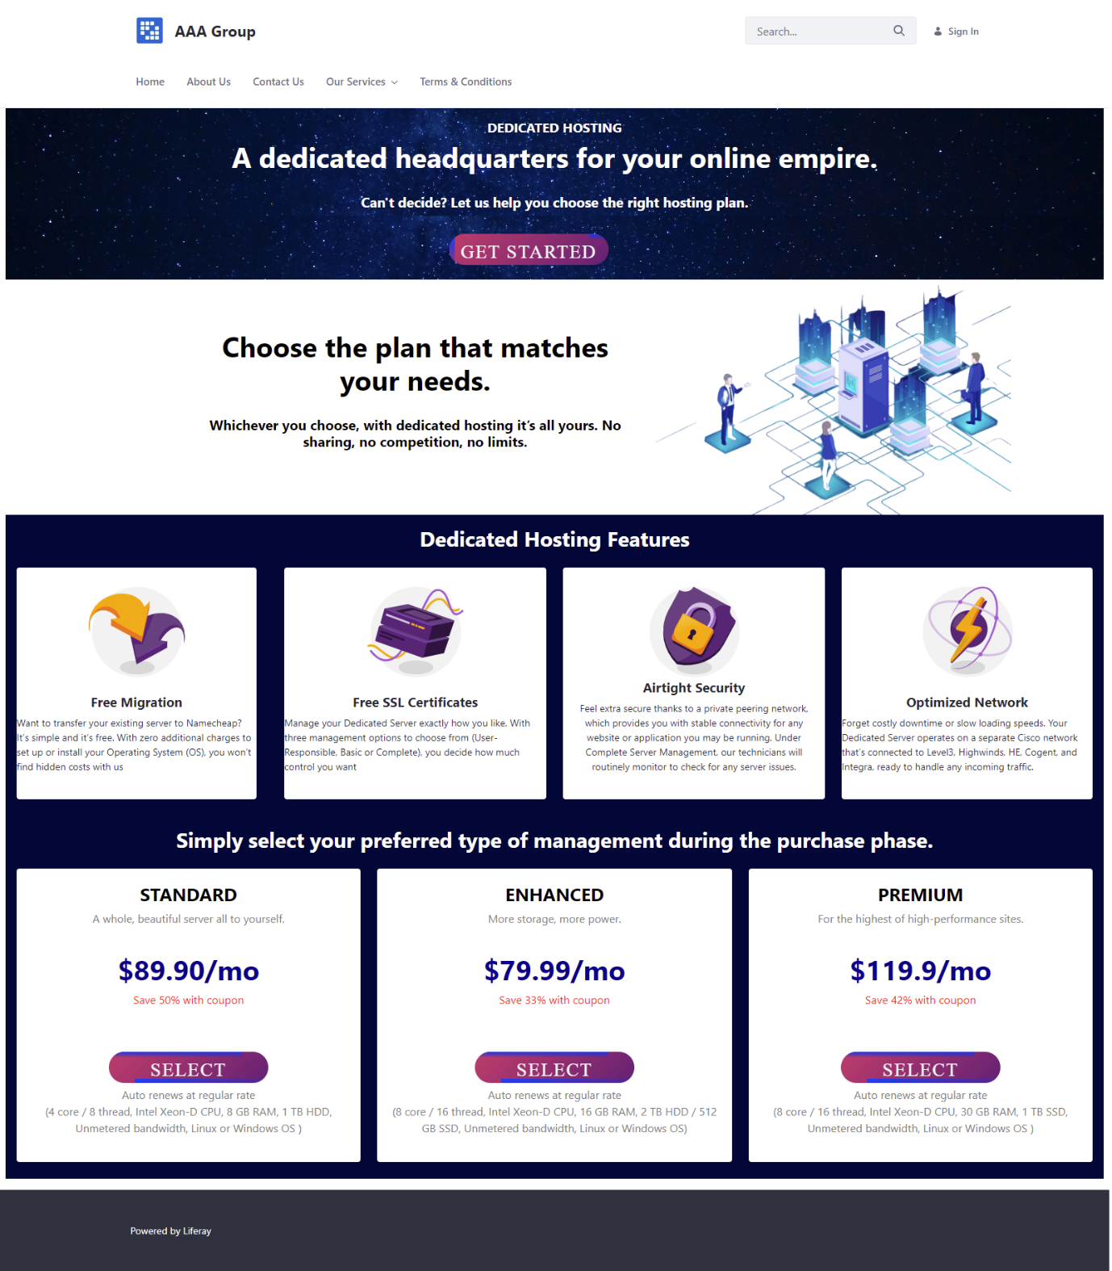

Figure 55:Screenshot of Dedicate Hosting Page

* **Colocation Server**

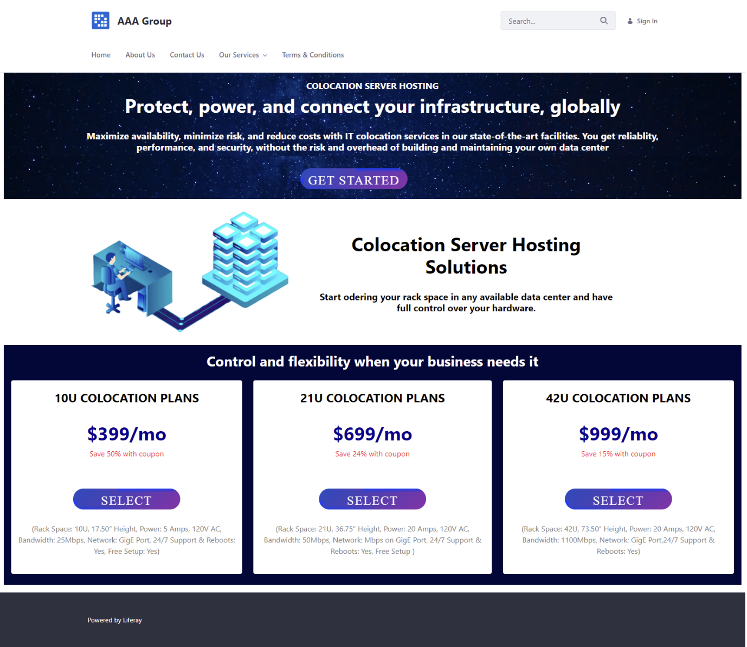

Figure 56:Screenshot of Colocation Server Hosting Page

* Manage Service & Customer
* Service

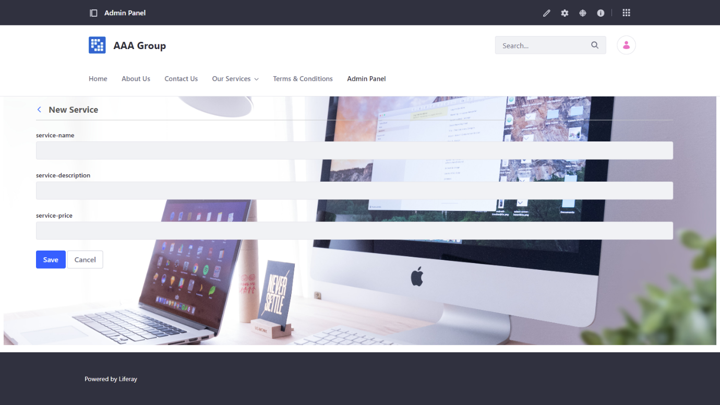

Figure 57:Screenshot of Service 1

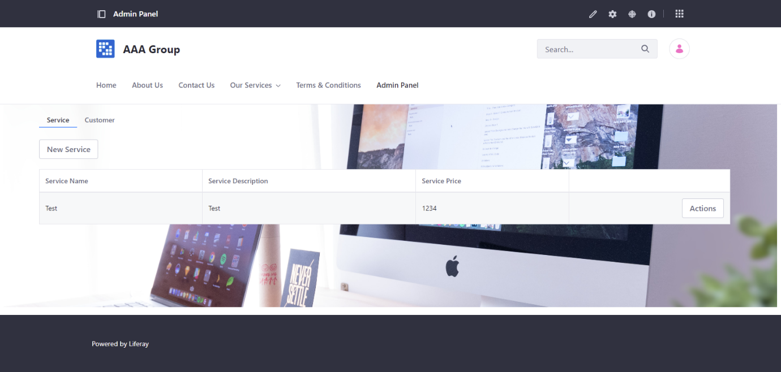

Figure 58::Screenshot of Service 2

* 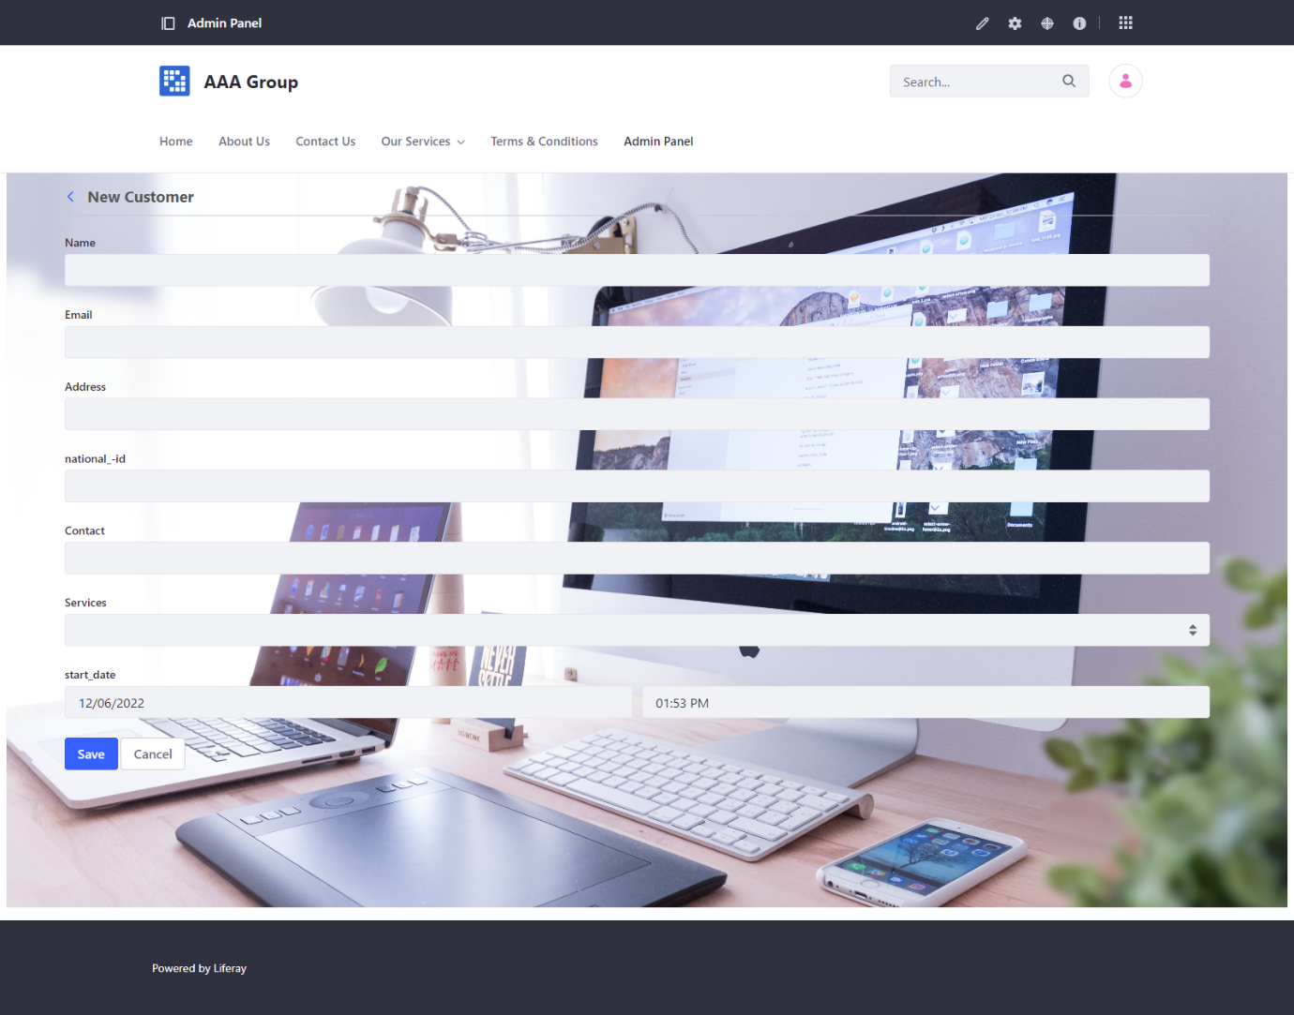**Customer**

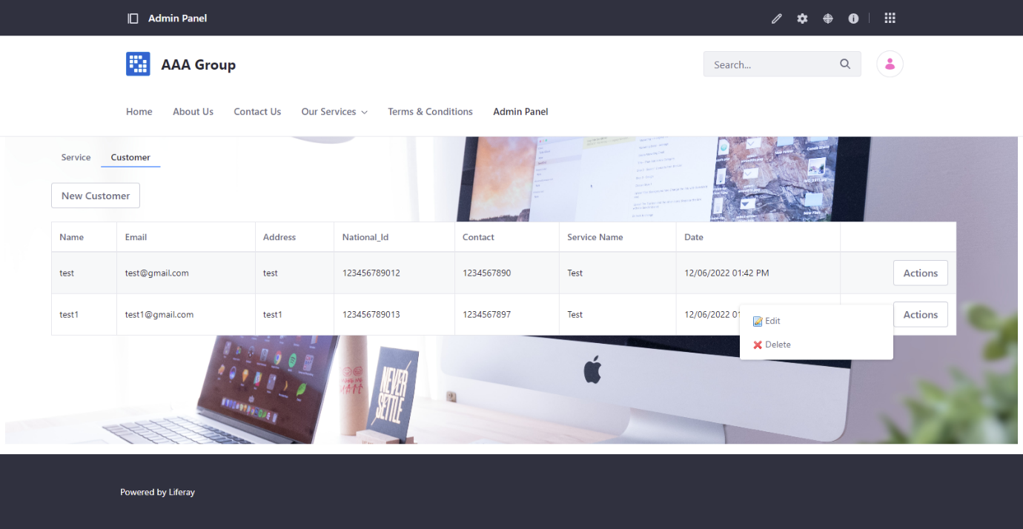

Figure 59:Screenshot of Customer 2

Figure 60:Screenshot of Customer 1

* **Terms & Conditions**

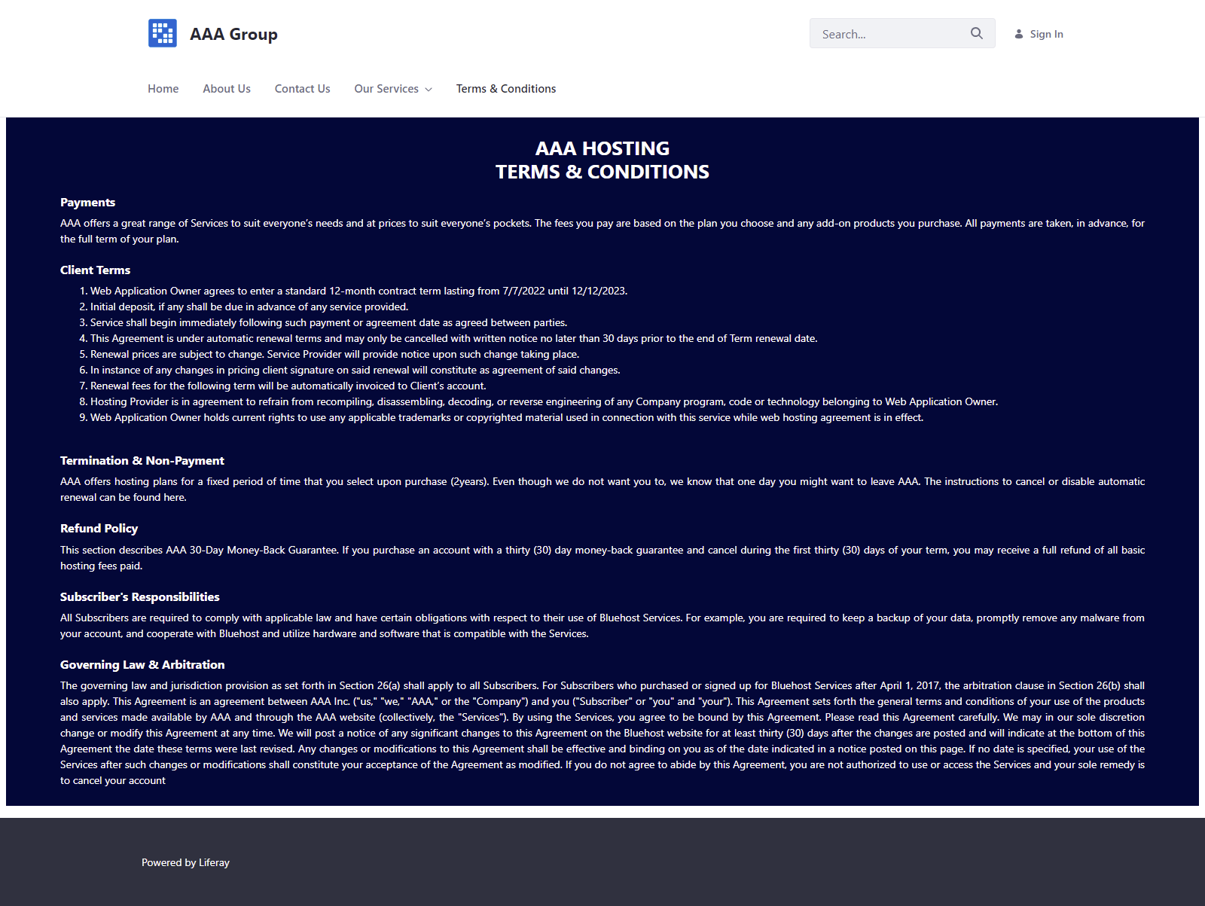

Figure 61:Screenshot of terms & condtions

1. **Screen capture of logging in with three different users (Administrator, Site Member) showing Permission for Customer and Service Portlet.**

* **Administrator**

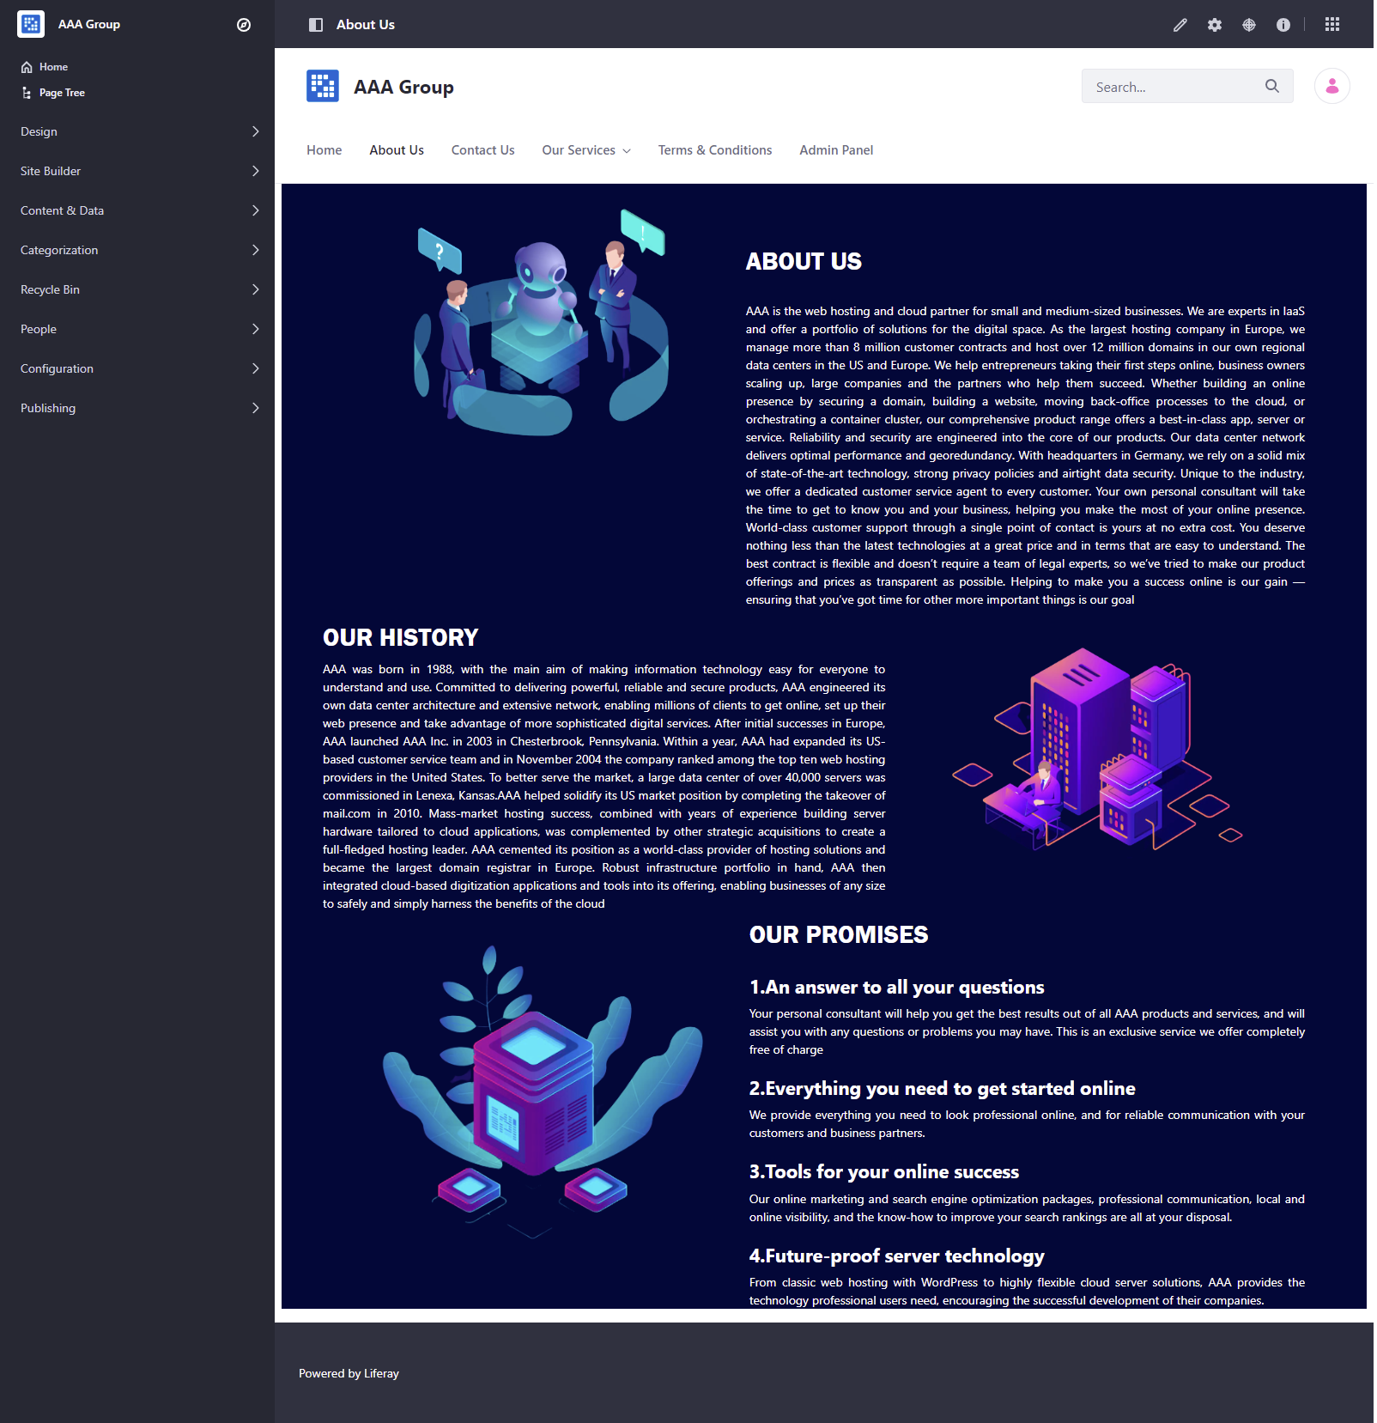

Figure 62:Screenshot of Administrator Login

* **Customer**

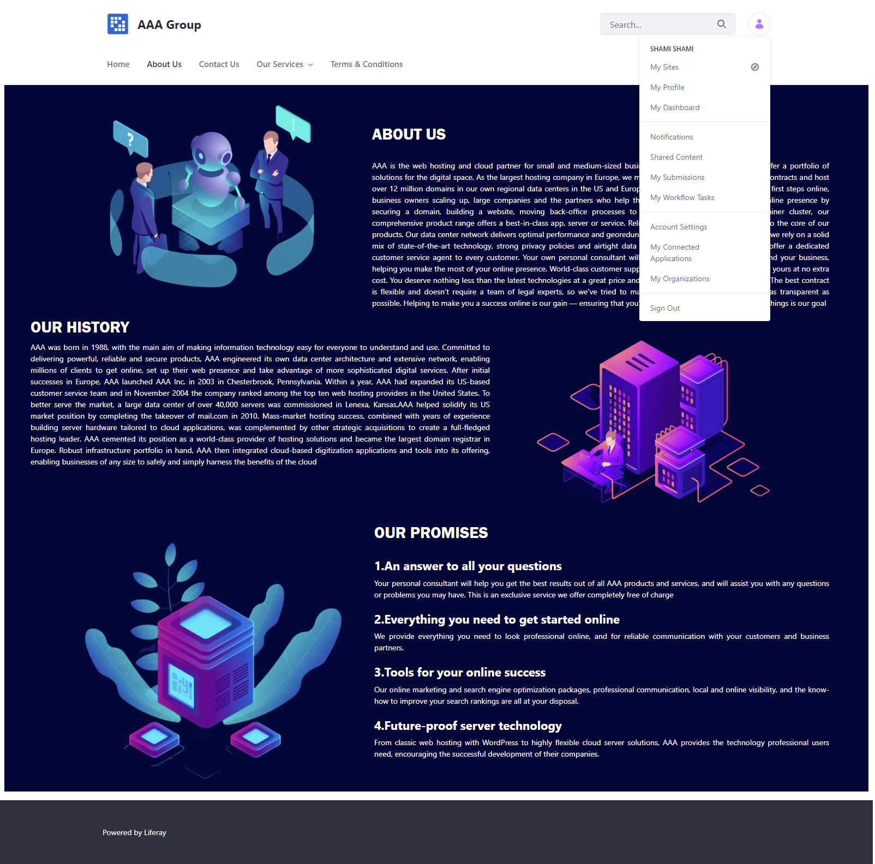

Figure 63:Screenshot of Customer Login

* **Site Member**

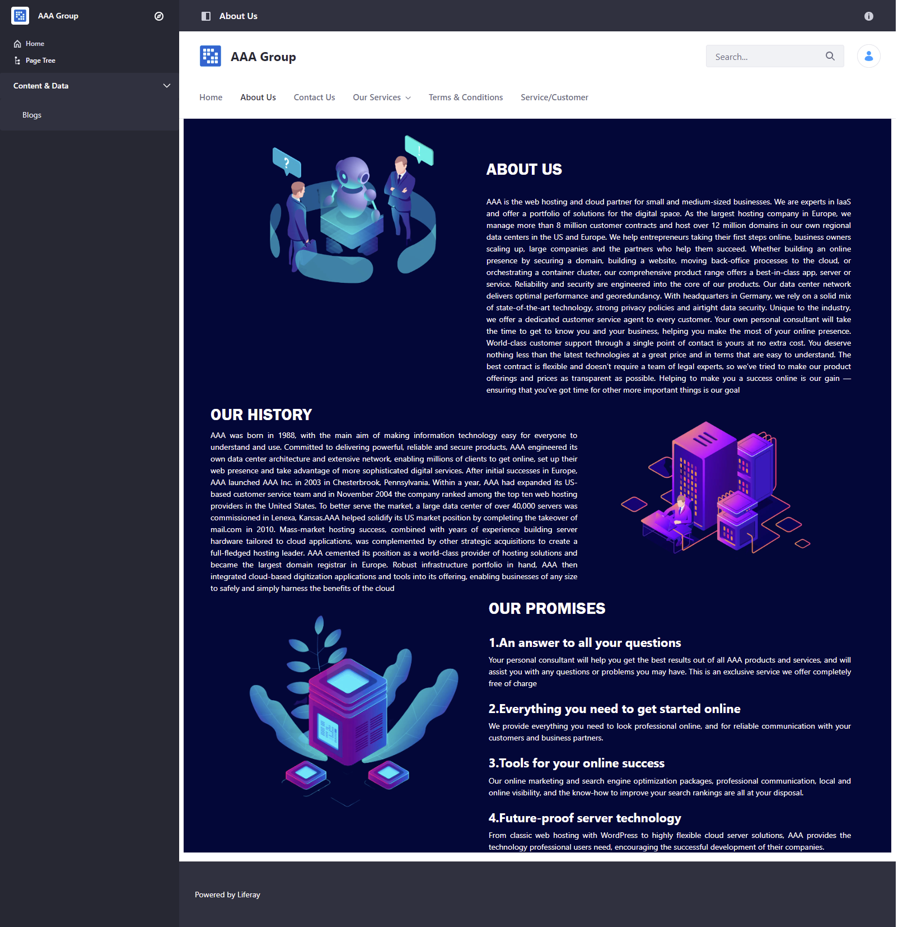

1. **The techniques have been utilized to produce secure code**

* Encapsulation

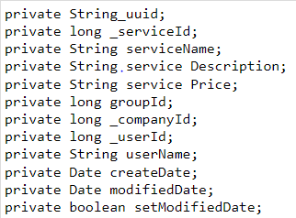

Figure 64:Source Code Example for Encapsulation

* 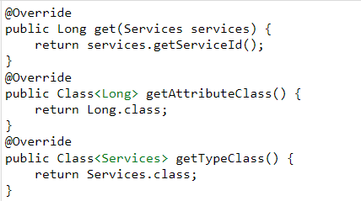Polymorphism

Figure 65:Sourcr code example for Polymorphism

* 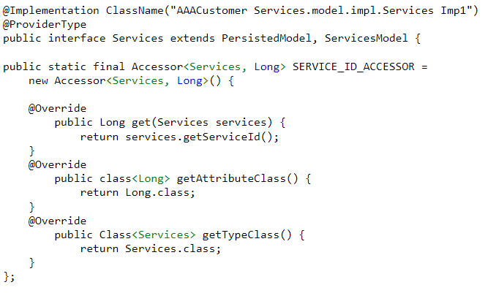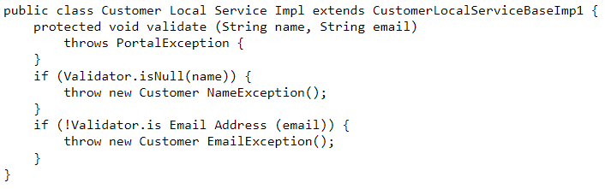Abstraction

Figure 66:Source Code Example for Inheritance

Figure 67:Source Code Example for Abstraction

* Inheritance

**Task 04**

1. **Use of design patterns for the given purpose and consequences by applying design patterns.**
   1. **Usage of design patterns in the “AAA Customer Management Portlet”**

Design patterns offer reusable solutions for common issues. It simplifies the software program. In addition, speeding up the development process is executed by making use of design patterns in applications. It is a platform that each developer can use. Design patterns provide a common language and are specific to a sure circumstance. As an illustration, the singleton design sample denotes using a single object, allowing all programmers who are familiar with it to use it and understand when a program is the used of it. Moreover, design patterns offer the best solution to the problems we come upon whilst developing software. The method of development may be sped up. Additionally, styles enable software designers to communicate the usage of broadly accepted nomenclature. Communal design patterns can be more advantageous over time, making them extra robust than ad-hoc designs.

• Using design patterns in the Triple-AAA Portlet is essential for keeping neat and smooth code.

• Despite the fact that the portlet has many layers of services and classes, no longer every design pattern can be beneficial whilst used by the portlet.

• We ought to use this information to determine the correct and optimal design pattern for the portlet. Because of a couple of layers of java classes, the portlet has already used the factory pattern. And, because we don't use any filtering functions in the portlet, the use of the filter pattern is probably now not a great pattern to adapt into it.

• Mainly given how the portlet implements the method and the fact that there are a couple of layers of java classes.

* 1. The consequences of design patterns that you have used in your project.

• Using the factory pattern in a portlet or any OOP project will bring about cleanser and tidier code, however if used excessively will bring about a huge number of required classes for major magnificence implementation.

1. **How different design patterns can work within a range of different scenarios.**

There are several design patterns and new ones are constantly being created as needed. One instance is the composite model , which is used to implement a tree structure. This may be a illustration of a folder with its sub- folders and the files discovered in them. Sheets and composites follow a model that makes use of the identical software program interface. The handling is the identical for every use.

The design situation gets rid of the need to distinguish among primitive objects and boxes. Individual objects and their combinations are treated within the identical manner.

If we think about singleton ,it limits the instantiation of a class to a single object .it is used in order that a single object coordinates operation inside a given system .it is mostly used for a system this is faster or takes up much less reminiscence .It additionally a device inside with few objects. Iterators and adapters are also a number of the main design patterns.

Iterators allow access to the element of a set without always having expertise of the technical info related to it. That is considered one of most frequently used design patterns.

As for the adapter, it lets in changing one interface into another that is exploited by an software .way to this model ,it's far possible to connect collectively interfaces that had been incompatible at first sight .that is also a frequently used procedure.

**1. Creational Design Pattern**

* **Factory Pattern**

Factory pattern is one of the most used design patterns in Java. This kind of design pattern comes under creational pattern as this pattern provides one of the high-quality approaches to create an item.

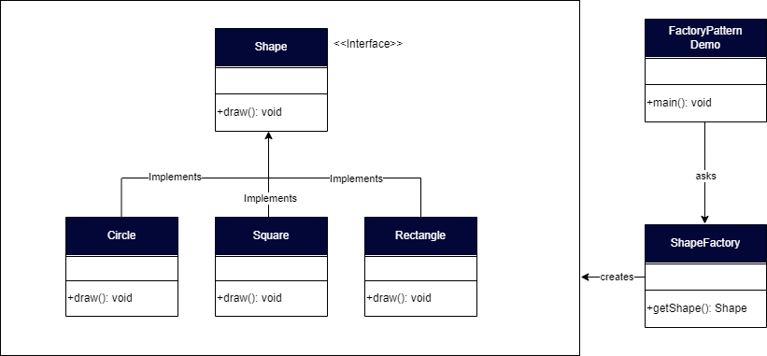In factory pattern, we create object without exposing the introduction logic to the consumer and refer to newly created object using a common interface.

Figure 68:Factory Pattern

* **Singleton**

Singleton pattern is one of the only design patterns in Java. This form of design pattern comes beneath creational pattern as this pattern affords one of the quality ways to create an object.

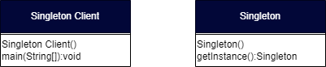This pattern includes a single class which is responsible to create an object even as making sure that simplest single object gets created. This class gives a way to get entry to its simplest object which may be accessed directly without need to instantiate the object of the class

Figure 69:Singleton

* **Prototype**

Prototype pattern refers to creating duplicate object whilst maintaining performance in thoughts. This sort of design pattern comes underneath creational pattern as this pattern provides one of the quality approaches to create an item.

This pattern includes imposing a prototype interface which tells to create a just like the present day object. This pattern is used when advent of object at once is costly. for instance, an object is to be created after a highly-priced database operation. we are able to cache the object, returns its clone on subsequent request and replace the database as and when needed for this reason reducing database calls

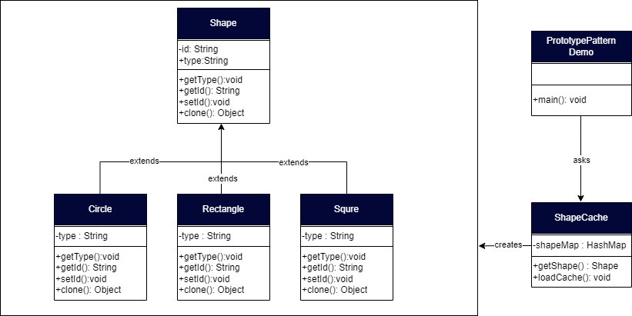

Figure 70:Prototype

**2. Structural Design Pattern**

* **Adapter Pattern**

In software program engineering, the adapter pattern is a software design pattern that lets in the interface of an present class to be used as another interface. it's miles regularly used to make current classes work with others without modifying their supply code.

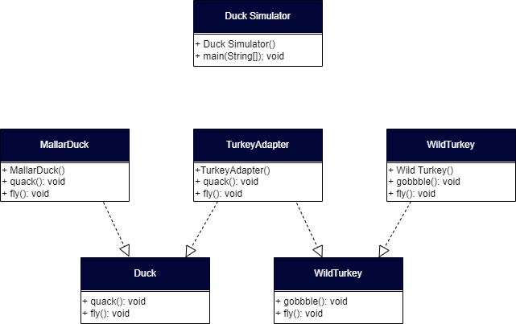

Figure 71:Adapter Pattern

* **Façade Pattern**

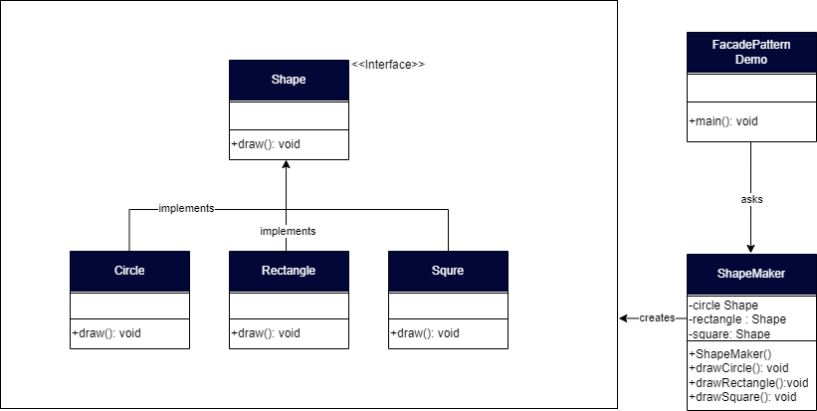The facade pattern is a software program-design pattern generally used in object-orientated programming. Analogous to a facade in architecture, a facade is an object that serves as a front-facing interface covering more complex underlying or structural code.

Figure 72:Facade Pattern

1. **Behavioral Design Pattern**

* **Iterator pattern**

In item-orientated programming, the iterator pattern is a design pattern wherein an iterator is used to traverse a box and get right of entry to the container's elements. The iterator pattern decouples algorithms from containers; in a few cases, algorithms are necessarily container-precise and hence cannot be decoupled

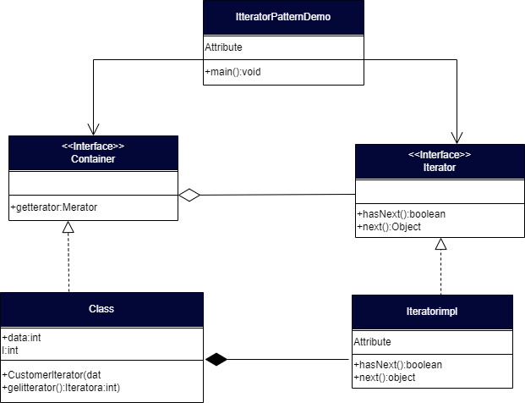

Figure 73:Iterator Pattern

* **Observer Pattern**

In software design and engineering, the observer pattern is a software program design pattern wherein an object, named the subject, maintains a list of its dependents, referred to as observers, and notifies them automatically of any state changes, generally with the aid of calling one in all their methods.

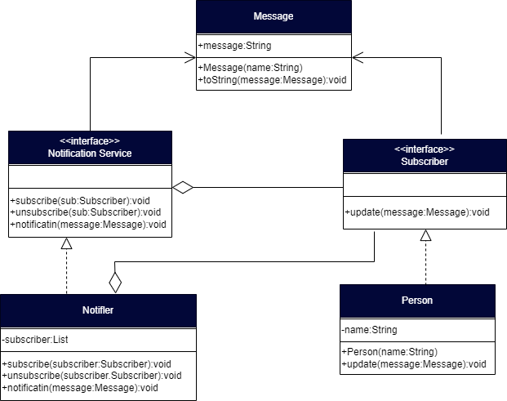

Figure 74:Observer Pattern

1. **The appropriate design pattern from the investigation.**
   1. Among 3 different scenarios in creational design which you have analyzed in P4, reconcile the most appropriate design pattern

* **Factory Pattern**

The factory method sample may be used in a project to create an item with the aid of developing a runtime interface. factory patterns make code extra resilient, easier to modify, and much less established. as an example, we should simply exchange the implementation of a class because the purchaser is unaware of it. after all, it simplest presents interface code, now not implementation.

* 1. Among 3 different scenarios in structural design which you have analyzed in P4, reconcile the most appropriate design pattern
* **Composite Pattern**

The AAA Portlet has separate classes of users, each with thier own attributes and methods. through using a composite pattern, all the attributes are probably combined or grouped. method to a single website online member item and administrator. via using this method, the developer ought to control and regulate the site member or administrator’s less difficult features with less effort.

* 1. Among 3 different scenarios in behavioural design which you have analyzed in P4, reconcile the most appropriate design pattern
* **Template method/pattern**

Due to the fact we use many classes, a maximum of which share relatively comparable code, we should create a template for an abstract class with most of the people of the functions predefined, and then create any other class with a mild modification in accordance with the desired final results.

1. **Evaluate and justify the design patterns that you had identify in each of the scenarios.**

* **Factory Method Design Pattern**

Additionally, called a digital Constructor. When we do not know what are the sub lessons, we need to create we can use a factory method design pattern. Additionally, the determined class selects the advent of objects to its sub-lessons we can use the factory method design pattern.

* **Bridge Design Pattern**

Additionally, referred to as the Handler of body. Applying the Bridge layout sample improves the extensibility of the software. Additionally, we can disguise the implementation information from the patron. It's miles frequently used in locations wherein adjustments made in implementation does now not disturb the customer side.

* **Façade Design Pattern**

The facade pattern hides the complexity of the device and gives an interface to the patron the usage of with which the customer can get admission to the device. This type of design pattern belongs to the structural pattern because it adds an interface to the prevailing system to cover its complexity.

* **Prototype**

This pattern makes it viable to clone current objects without code. Because this type of operation isn't class-dependent.

* **Composite**

This is a pattern that gives an association of objects in the shape of a tree shape. Although it is inside the form of a tree, the item continues to be handled as an individual object.

* **Template methods**

Template methods are behavioral design patterns that define the framework of an algorithm within the superclass however allow the subclass to override certain steps of the algorithm without converting its structure.

**Task 05**

1. Screen capture of developed pages and hosted application in Project Presentation.

* 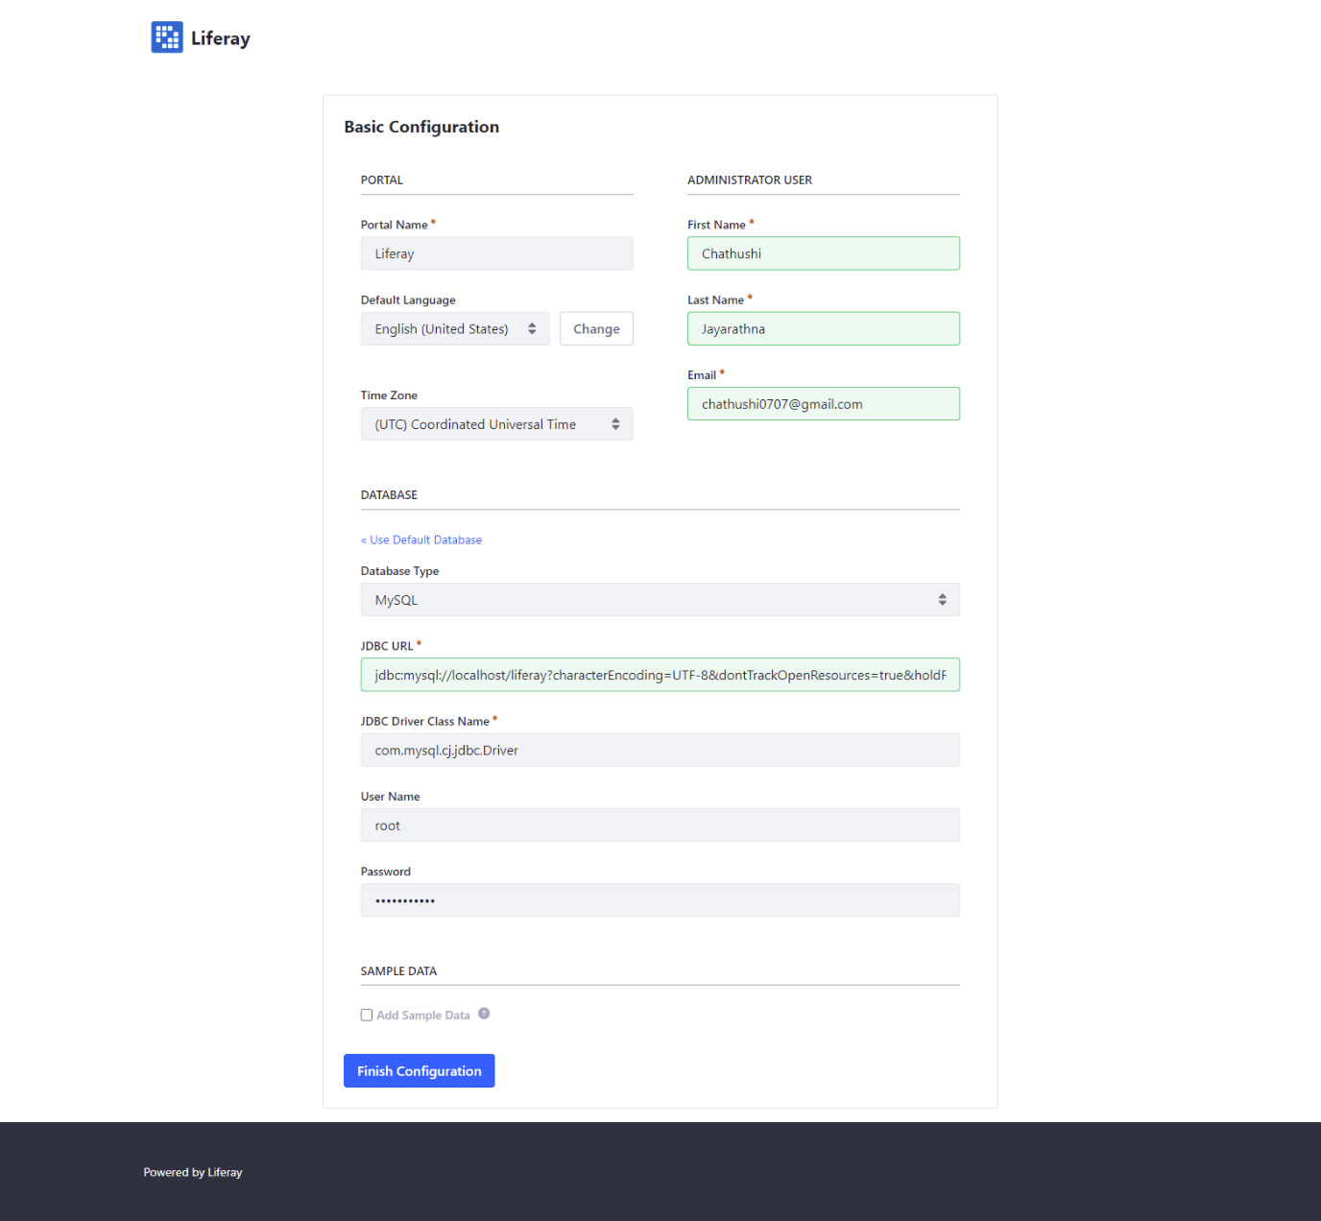**Registration**

Figure 75:Screenshot of Registration page

* 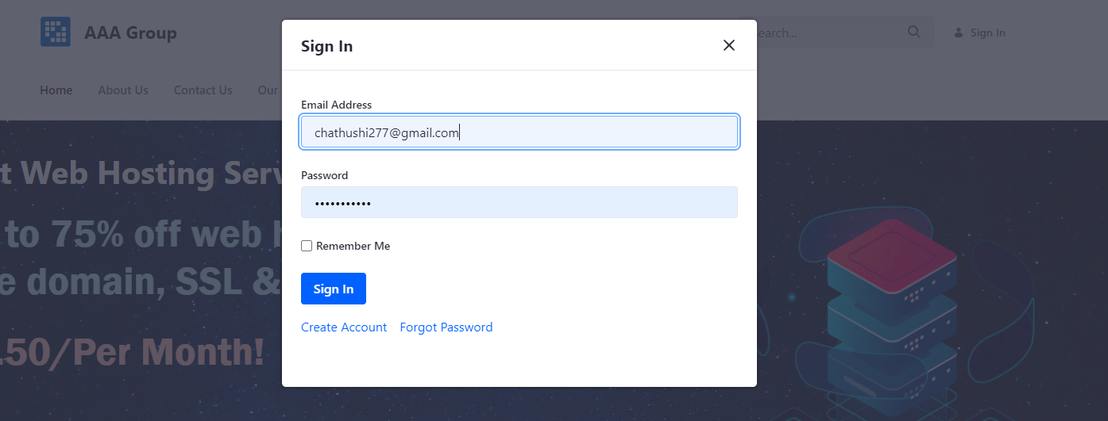**Login**

Figure 76:Screenshot of Login page

* **Terms & Conditions**



Figure 77:Screenshot of Terms & Conditions

* **Home page**



Figure 78:Screenshot of Home Page

* **About Us**



Figure 79:Screenshot of About us Page

* **Contact Us Page**



Figure 80:Screenshot of Contact us page

* **Our Services**

Figure 81:Screenshot of our service page

* **Domain Name**



Figure 82:Screenshot of Domain Name Page

* **Shared Hosting**



Figure 83:Screenshot of Shared Hosting Page

* **Reseller Hosting**



Figure 84:Screenshot of Reseller Hosting Page

* **Cloud Hosting**



Figure 85:Screenshot of Cloud Hosting Page

* **VPS Hosting**



Figure 86:Screenshot of VPD Hosting Page

* **Dedicated Hosting**



Figure 87:Screenshot of Dedicated Hosting Page

* **Colocation Server**



Figure 88:Screenshot of Colocation Server Hosting Page

* Manage Service & Customer
* Service



Figure 90:Screenshot of Service 1

Figure 89:Screenshot of Service 2

* **Customer**



Figure 91:Screenshot of Customer 2

Figure 92:Screenshot of Customer 1